

STORMWATER POLLUTION PREVENTION PLAN

for

Facilities Management Yard
Date: August 1, 2016
MS4 Permit Number: VAR040073
Date of Most Recent Update :
September 25, 2026

Prepared by:

Environmental Resources
University of Virginia
P.O. Box 400726
Charlottesville, VA 22904-4726

TABLE OF CONTENTS
CERTIFICATION 3
1.0 INTRODUCTION 4
1.1 Purpose 4
1.2 SWPPP Content 4
2.0 FACILITY INFORMATION 5
2.1 Facility Location 5
2.2 Facility Description and Activities 6
2.3 Facility Stormwater Drainage System 7
3.0 IDENTIFICATION OF POTENTIAL STORMWATER CONTAMINANTS 8
3.1 Potential Pollutants and Pollutant Sources 8
3.2 Potential Nonstormwater Discharges 10
4.0 POLLUTION PREVENTION, GOOD HOUSEKEEPING PRACTICES, AND STRUCTURAL CONTROL MEASURES 11
4.1 Written Procedures for Operations and Maintenance Activities 11
4.2 Written Procedures for High-Priority Facility Activities 14
4.3 Structural Control Measures 15
5.0 EMPLOYEE TRAINING 15
6.0 FACILITY INSPECTIONS AND PREVENTATIVE MAINTENANCE PLAN 16
6.2 Preventative Maintenance 16
6.3 Changes to Site Operations 16
7.0 NOTICE OF PLANNED CHANGES 17
8.0 RECORD RETENTION REQUIREMENTS 17

APPENDICES

Appendix A Standard Operating Procedures for this High-Priority Facility
Appendix B Annual Comprehensive Site Compliance Evaluation Checklist
Appendix C Annual Inspection Reports
Appendix D Log of Changes and Updates to SWPPP

CERTIFICATION
I certify that I have read and understand this document and that this document and all attachments were prepared in accordance with a system designed to assure that qualified personnel properly gathered and evaluated the information submitted. Based on my inquiry of the person or persons who manage the system or those persons directly responsible for gathering the information, the information submitted is to the best of my knowledge and belief true, accurate, and complete.

Authorized By: _Donald E. Sundgren______________
Title: _Vice President and Chief Facilities Officer___________________

A signed version of this document is available upon request by emailing storm-water@virginia.edu

Signature: ____________________________________ Date: __9/25/2026_______________

1.0 INTRODUCTION

1.1 Purpose
The University of Virginia (UVA) is subject to a General Permit for Discharges of Stormwater from Small Municipal Separate Storm Sewer Systems (MS4s). This permit requires that UVA identify high-priority locations requiring Stormwater Pollution Prevention Plans (SWPPP). These plans are designed to minimize or prevent pollutant discharge from daily operations such as road, street, and parking lot maintenance, equipment maintenance, and the application, storage, transport, and disposal of fuels, chemicals, pesticides, herbicides, and fertilizers.
UVA has developed this SWPPP to incorporate the requirements of the MS4 Permit. UVA must identify all high-priority facilities, which means facilities owned or operated by UVA with drainage to any permitted MS4 that actively engage in one or more of the following activities:
- Composting;
- Equipment storage, cleaning, and maintenance;
- Long term bulk materials storage;
- Pesticide, herbicide, and fertilizer storage ;
- Recycling;
- Anti-icing and deicing agent storage, handling, and transfer;
- Solid waste handling and transfer; and
- Vehicle washing, maintenance, and salvage.

The primary goals of the SWPPP will be to:
- Identify potential sources of pollutants that affect stormwater discharges from this facility;
- Describe the practices that will be implemented to prevent or control the release of pollutants in stormwater discharges; and
- Create an implementation schedule to ensure that the practices described in this SWPPP are in fact implemented and to evaluate the plan’s effectiveness in reducing the pollutant levels in stormwater discharges.

1.2 SWPPP Content
This SWPPP includes the following:
- A site description that includes a site map identifying all outfalls, direction of stormwater flows, existing source controls, and receiving water bodies;
- A description and checklist of potential pollutants and pollutant sources;
- A description of all potential nonstormwater discharges;
- A description of all structural control measures, such as stormwater management facilities and other pollutant source controls, applicable to SWPPP implementation such as oil-water separators, and inlet protection designed to address potential pollutants and pollutant sources at risk of being discharged to the MS4;
- A maintenance schedule for all stormwater management facilities and other pollutant source controls applicable to SWPPP implementation as described in 1.2.f.
- Site specific written procedures designed to reduce and prevent pollutant discharge that incorporate by reference applicable good housekeeping procedures required by the permit;
- A description of the applicable training as required;
- An inspection frequency of no less than once per year and maintenance requirements for site specific source controls. The date of each inspection and associated findings and follow-up shall be logged in each SWPPP;
- A log of each unauthorized discharge, release, or spill incident reported in accordance with permit requirements including the date of incident; material discharged, released, or spilled; and estimated quantity discharged, released, or spilled;
- A log of modifications to the SWPPP made as the result of any unauthorized discharge, release, or spill in accordance with permit requirements or changes in facility activities and operation requiring SWPPP modification.
- The point of contact for SWPPP implementation.

2.0 FACILITY INFORMATION

2.1 Facility Location
Facility Name: Facilities Management (FM) Yard
Facility Address: 575 Alderman Road, Charlottesville, VA 22904
Facility Acreage: 8.7 acres
University’s Primary SIC Code: 8221
Watershed this facility drains to: Meadow Creek
Moore’s Creek
Facility Point of Contact Kristin Carter: 434-982-5034, Email Kristin

2.2 Facility Description and Activities
The total area of the site is approximately 9 acres, which is mostly impervious surface consisting of parking lots and buildings (Figures 1-2). The parking lot includes approximately 4,800 square feet of porous asphalt, approximately 6,100 square feet of pervious concrete, and a vehicle wash area with a 700-gallon cistern.

The site contains administrative and shop buildings for the multiple functions performed by FM. The activities include parking areas for FM fleet vehicles, storage and washing of miscellaneous equipment, receiving and disbursement of fuels, building materials, tools, and chemicals used in operations and maintenance, and storage of salt and sand used for pavement deicing, and spreaders used by Landscaping for road and parking lot treatment. A gasoline fueling pump, which is operated by Parking and Transportation, is located on site and served by an underground storage tank. The list below includes departments that may have an impact on stormwater pollution potential at the FM Yard due to activities performed and materials used during work procedures:

- Custodial Services
- Cabinet Shop
- Facilities Receiving
- Fire Protection
- Fleet Management
- Landscaping
- Power and Light Operations
- Trades
- Painting
- Sign Shop
- Snow and Ice Control
- Utilities
- UVA Recycling
- Re-Use Store

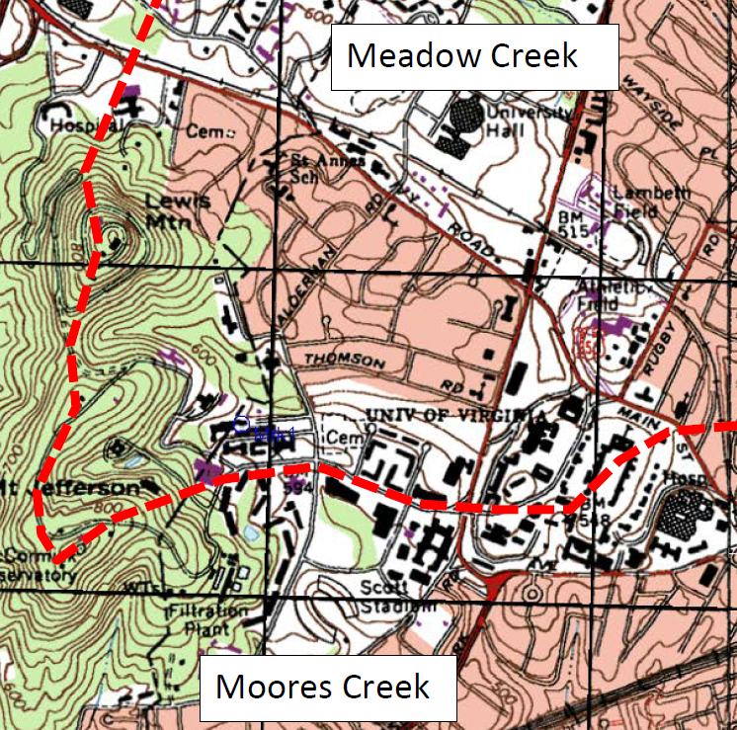
Figure 1. Facility USGS Topographic Location Map. The red line shows the watershed divide, while the yellow box shows location of FM Yard in relation to Meadow Creek watershed.
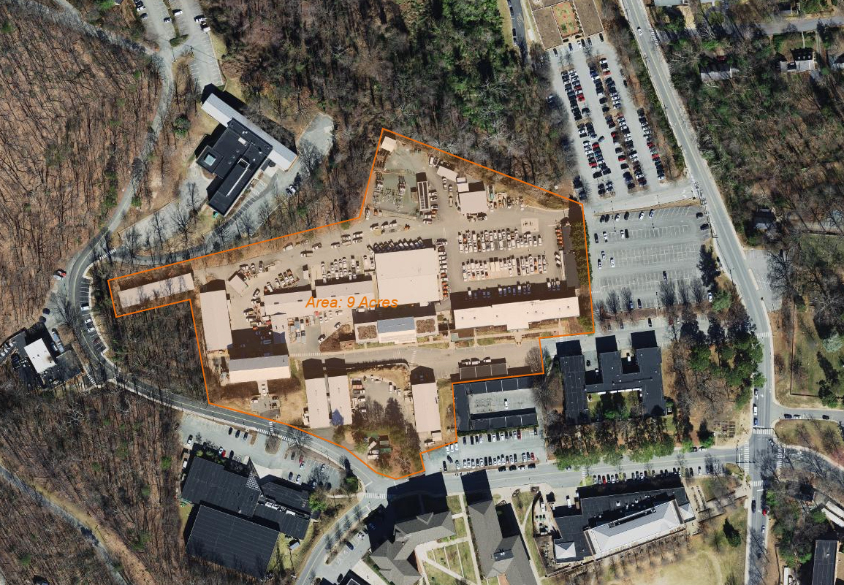
Figure 2. Aerial Photograph of Site and Vicinity

2.3 Facility Stormwater Drainage System
Meadow Creek enters the site west of the Landscape Shop in a steep and wooded area of the Yard. The stream descends the slope and then enters pipes which run under the entire length of the FM Yard. Other smaller tributaries join with the main stem of the stream to become part of Meadow Creek, which can be seen on the surface of the Yard to the north of the main entry gate. The Meadow Creek is considered an “impaired” waterway for sediment by the Virginia Department of Environmental Quality. All the surface catch basins (CB) and drop inlets (DI) along the FM Yard drain into the University’s MS4 (Figure 3). UVA’s MS4 then discharges stormwater into the City of Charlottesville’s MS4 which flows on the surface or in pipes, ultimately discharging to the Rivanna River.
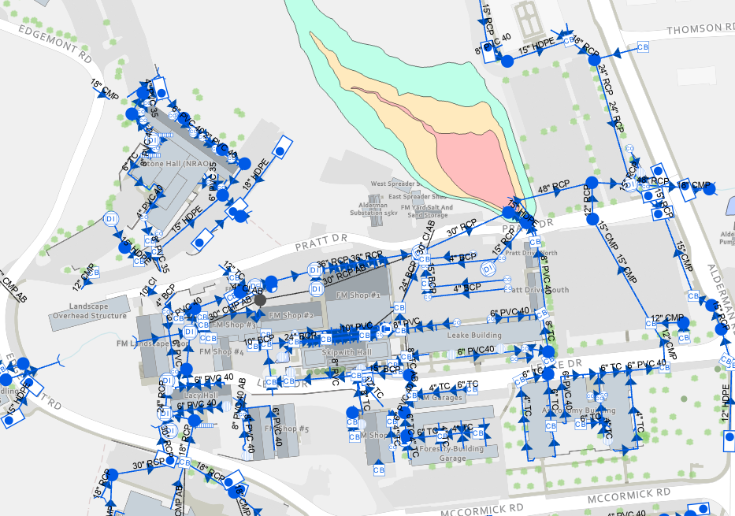
Figure 3. Facility Stormwater Drainage System.

3.0 IDENTIFICATION OF POTENTIAL STORMWATER CONTAMINANTS
This section identifies significant materials located at the high-priority facility that may potentially contaminate stormwater and locates areas where stormwater contamination may occur. Potential non-stormwater sources are also described.

3.1 Potential Pollutants and Pollutant Sources
Materials used by the facility that have the potential to be pollutants are listed in Table 1. This table includes the material description, the source of the potential pollutant, its location and potential risk.
Table 1. Checklist of Potential Pollutants and Sources*
Description of Material/Pollutant | Pollutant Source | Location of Pollutant | Potential Risk
Fuel | Delivery vehicles | Vehicle fueling pumps, NE quadrant of site | High risk – large quantity, outdoors
Fuel | Delivery, leaking tank | Emergency generators, Stand-alone tank | High risk – large quantity, outdoors
Fuel, oil, grease for equipment | Storage, spill | Landscape structure, shops, procurement | Medium risk – some stored outdoors or under cover
Equipment and vehicles | Leak | Parking areas, drive aisles and loading docks | Medium risk –Vehicles kept in good repair and receive routine maintenance to minimize risk of leaks.
Cleaning solvents | Storage, spill | Housekeeping closets | Low risk - indoors
Detergents | Storage, spill | Wash area near shed in yard | Medium risk – space is upgradient from storm drains, pad drains to sanitary
Fertilizers | Storage, spill | Landscape | Medium risk – stored outdoors under cover
Pesticides, herbicides | Storage, spill | Landscape | Medium risk – stored in locked cabinet
Coatings, adhesives, wood preservatives | Storage, spill, cleaning | Cabinet shop | Low risk - indoors
Mortar mix, concrete | Washing tools | Shops building | Low risk - indoors
De-icing agents | Spill | Landscape structure | Medium risk – used and stored outdoors under cover
Sawdust | Wood working | Cabinet Shop dust collector dumpster | Medium risk
Mixed effluents | Stormwater run-off | Trash dumpsters | Medium risk
Salt and Sand | Bulk piles | Salt/Sand Shed | Medium risk – under cover, but chance of tracking
Salt and Sand | Spill | Spreader Sheds | Low risk – under cover

*Rather than utilize a traditional checklist to indicate presence or absence of potential risks, this checklist directly identifies pollutants, sources, locations, and the known potential risk.

3.2 Potential Nonstormwater Discharges
Table 2 identifies all nonstormwater discharges as authorized in the general permit that are or could be commingled with stormwater discharges from the high-priority facility, including any applicable support activity. Potential authorized nonstormwater discharges include:
Table 2. Potential Nonstormwater Discharges
Authorized Nonstormwater Discharges that could be Commingled with Stormwater Discharges at this Facility | Anticipated?
a. Water line flushing, managed in a manner to avoid an instream impact | Yes No
b. Landscape irrigation | Yes No
c. Diverted stream flows | Yes No
d. Rising groundwaters | Yes No
e. Uncontaminated groundwater infiltration, as defined at 40 CFR 35.2005(20) | Yes No
f. Uncontaminated pumped groundwater | Yes No
g. Discharges from potable water sources managed in a manner to avoid instream impact | Yes No
h. Foundation drains | Yes No
i. Air conditioning condensation | Yes No
j. Irrigation water | Yes No
k. Springs | Yes No
l. Water from crawl space pumps | Yes No
m. Footing drains | Yes No
n. Lawn watering | Yes No
o. Individual residential car washing | Yes No
p. Flows from riparian habitats and wetlands | Yes No
q. Dechlorinated freshwater swimming pool discharges managed in a manner to avoid instream impact | Yes No
r. Street and pavement wash waters that do not contain cleaning additives or are otherwise managed in a manner to avoid instream impact | Yes No
s. Routine external building washdown provided no soaps, solvents, or detergents are used, external building surfaces do not contain hazardous substances, and the wash water is filtered, settled, or similarly treated prior to discharge | Yes No
t. Discharges or flows from emergency firefighting activities | Yes No
u. Discharges or flows of water for fire prevention or firefighting training activities managed in a manner to avoid instream impact in accordance with § 9.1-207.1 of the Code of Virginia | Yes No
v. Discharges from noncommercial fundraising car washes if the washing uses only biodegradable, phosphate-free, water-based cleaners in accordance with § 15.2-2114.1 of the Code of Virginia | Yes No
w. Other activities generating discharges identified by the department as not requiring VPDES authorization | Yes No

4.0 POLLUTION PREVENTION, GOOD HOUSEKEEPING PRACTICES, AND STRUCTURAL CONTROL MEASURES
Each UVA facility that has been identified as a high-priority facility and conducts any of the activities listed in Section 4.2 that are expected to have exposure to stormwater must develop and implement site specific written SWPPP designed to reduce and prevent pollutant discharge.

4.1 Written Procedures for Operations and Maintenance Activities
UVA has developed procedures to reduce and prevent pollutant discharge on the site where potential contaminates may be washed into stormwater channels, sewer systems, or ground water. If a procedure is not relevant to the location, a comment has been entered that explains why this procedure is not applicable. In addition to the items noted below, UVA has developed a list of Standard Operating Procedures covering many operations and maintenance activities. The pertinent SOPs to this high-priority facility are listed in Appendix A and referred to below where applicable. All listed SOPs are available online at the Environmental Resources Website.
4.1.1 Prevent illicit discharges:
An illicit discharge as defined in 9VAC25-875-850 “means any discharge to a municipal separate storm sewer that is not composed entirely of stormwater, except discharges pursuant to a separate VPDES or permit (other than the permit for discharges from the municipal separate storm sewer), discharges resulting from firefighting activities, and discharges identified by and in compliance with 9VAC25-875-970 D.2.c(3)v.” In the FM Yard, the operators will maintain structural stormwater controls, maintain clean lots and roads, keep materials under canopies, control pollutants such as pesticides, herbicides and fertilizers, and contain and report spills that may discharge into the MS4. UVA has an SOP to identify and report illicit discharges, as well as many SOPs that focus on preventing illicit discharges. UVA also has developed a program for spill response, including a spill response SOP, to try to prevent illicit discharges before they occur.
4.1.2 Ensure staff or contractors properly dispose of waste materials, including landscape wastes and prevent waste materials from entering the MS4:
Waste materials from offices, shops, and garages shall be disposed of in appropriate trash and recycling containers. Organic, non-toxic landscaping wastes from plant installation, pruning, and removal will be sent to the vegetative debris collection site located on Observatory Hill. UVA has developed SOPs to ensure the proper disposal of waste materials including an SOP on Waste Management and one on Landscape Materials and Organic Waste.
4.1.3 Prevent the discharge of wastewater or wash water not listed as an allowable nonstormwater discharge (Table 2) into the MS4 without authorization under a separate VPDES permit:
Passenger and service vehicles are washed at the FM Yard vehicle wash area according to the FM Yard Vehicle and Equipment Wash Locations SOP or at a public car wash. UVA has also developed an SOP on Exterior Surfaces Washing.
4.1.4 Minimize the pollutants in stormwater runoff:
Potential pollutant sources are stored to avoid contact with stormwater runoff, as previously noted in Table 1. For example, the salt and sand shed prevents stormwater contact with these erodible materials. Fertilizers and other chemicals are stored under cover at the landscape storage area to the northeast of the Landscape Shop or under the T-shed.
4.1.5 Implement best management practices related to road, street, sidewalk, and parking lot maintenance and cleaning.
UVA has developed an SOP on Road, Street, Sidewalk, and Parking Lot Maintenance, Cleaning, and Anti-Icing and Deicing Application, Transport, and Storage (abbreviated “Road and Sidewalk Maintenance, Cleaning, and Deicing”). Use of agents containing urea or other forms of nitrogen or phosphorus are not purchased.
4.1.6 Implement best management practices related to renovation and significant exterior maintenance activities (e.g., painting, roof resealing, and HVAC coil cleaning) not covered under a separate VSMP construction general permit.
UVA has developed an SOP on Renovation and Significant Exterior Maintenance Activities that covers the required activities. UVA has also developed an SOP on Exterior Surfaces Washing which applies to washing of any building surfaces and equipment such as exterior HVAC equipment.
4.1.7 Require implementation of best management practices when discharging water pumped from construction and maintenance activities not covered by another permit covering such activities:
No water from construction and maintenance activities are discharged at this site under normal operations. If the FM Yard has construction activity that involves the discharge of pumped water, UVA staff or contractors involved will follow the SOP on Water Disposal from Dewatering Activities.
4.1.8 Implement best management practices related to the temporary storage of landscaping materials.
UVA has an SOP regarding Landscape Materials and Organic Waste, which includes provisions for short term storage of materials to avoid impacts to storm drains, conveyances, and streams. Berms will be used at the base of piles if appropriate and if rain is forecast or the pile will remain on site longer than 48 hours, materials will be covered.
4.1.9 Maintenance of owned and operated vehicles and equipment to prevent pollutant discharge into the MS4 from leaking vehicles and equipment:
The FM Fleet Team administers the assignment, safe utilization, maintenance, repair and replacement of fleet vehicles and equipment. FM Fleet vehicles are subject to routine preventative maintenance. The employees of FM who notice any fleet vehicles that are leaking shall report these to the Fleet Manager so that repairs can be made as soon as possible. These vehicles will be taken for maintenance repairs and any spills will be cleaned up following the procedures described in the Spill Response SOP. UVA has developed an SOP on Vehicle and Equipment Maintenance.
4.1.10 Ensure that the application of materials, including pesticides and herbicides, shall not exceed manufacturer's recommendations. Application of fertilizer shall not exceed maximum application rates established by applicable nutrient management plans.
UVA has multiple Nutrient Management Plans to moderate the use of fertilizer on all state-owned lawn and landscape areas. Yearly inspections of records and licenses are conducted to ensure compliance with the Plans. Pesticide types and storage locations at the FM Yard are checked annually to ensure containers are properly labeled, access to the area is restricted to authorized personnel, and storage cabinets are appropriately labeled. Certified Applicators of pesticides or fertilizers must be recertified every two years. For those who are not certified to apply pesticides or fertilizers, they must be trained and supervised by a Certified Applicator. UVA has developed an SOP on Pesticides, Herbicides and Fertilizers.

4.2 Written Procedures for High-Priority Facility Activities
This section addresses the procedures UVA will follow to prevent pollutants from entering the MS4 from the following common activities that occur at high-priority facilities and are expected to have exposure to stormwater. The following items address the methods that will be used to prevent pollutants from entering the MS4. If an activity is not relevant to the FM Yard, a comment has been entered that explains why this procedure is not applicable.
4.2.1 Areas where residuals from using, storing or cleaning machinery or equipment remain and are exposed to stormwater:
UVA has a FM Yard Vehicle and Equipment Wash Location SOP that is followed for washing vehicles and equipment on site. The designated vehicle and equipment washing area in the FM Yard has a drain to the sanitary sewer. Sanitary sewer discharge from the vehicle wash area is treated by an oil water separator. There is also a drain that drains to the sanitary sewer under the small landscape roof (former recycling area) and in front of the salt and sand storage shed. Small incidental equipment washing may take place under the small landscape roof.
4.2.2 Materials or residuals on the ground or in stormwater inlets from spills or leaks:
Bulk piles of salt and sand are stored under cover and are not located near any stormwater inlets. All particulate residuals shall be swept up and disposed of into appropriate waste containers. Vehicles and equipment are kept in good repair as described in the Vehicle and Equipment Maintenance SOP. Fluid leaks will be handled according to the specific procedures described in the UVA Spill Response SOP.
4.2.3 Material handling equipment:
Material handling equipment such as forklifts are checked before every use by certified forklift operators. Part of their inspection includes observation for any mechanical problems that may be apparent. At this time, if the operator notices any leaks, the equipment would be taken out of service until repairs are completed. Material handling equipment is kept in good repair as described in the Vehicle and Equipment Maintenance SOP.
4.2.4 Materials or products that would be expected to be mobilized in stormwater runoff during loading or unloading or transporting activities (e.g., rock, salt, fill dirt):
These materials when purchased in bags are stored under the Landscape Shed and Salt/Sand Shed. Unloading and loading of bulk salt and sand will be aided by employees who will maintain the area to prevent escape of materials by runoff. UVA has developed an SOP titled Road and Sidewalk Maintenance, Cleaning, and Deicing which includes expectations for handling of materials stored under the Salt and Sand Storage Shed. UVA also has developed an SOP for Landscape Materials and Organic Waste, which covers the short-term storage of erodible landscape material to protect storm drains and streams.
4.2.5 Materials or products stored outdoors (except final products intended for outside use where exposure to stormwater does not result in the discharge of pollutants):
FM staff limit materials or products outside of this category (intended for final use outside or where exposure to stormwater does not result in the discharge of pollutants) from being stored outside except on a temporary basis until they can be moved to their roofed or indoor storage areas.
4.2.6 Materials or products that would be expected to be mobilized in stormwater runoff contained in open, deteriorated or leaking storage drums, barrels, tanks, and similar containers:
Any drums, barrels, and containers that are in storage at the FM Yard are in good condition and are kept either under a roof or indoors. Petroleum storage tanks with a capacity of 55 gallons or more are inspected monthly to verify they are in good condition and not leaking.
4.2.7 Waste material except waste in covered, non-leaking containers (e.g., dumpsters):
All waste materials will be disposed of into covered dumpsters or containers. As mentioned in section 4.1.2, UVA has developed SOPs to ensure the proper disposal of waste materials including an SOP on Waste Management, on the UVA Recycling Sorting Facility, and on Landscape Materials and Organic Waste.
4.2.8 Application or disposal of process wastewater (unless otherwise permitted):
No process wastewater is generated from this site.
4.2.9 Particulate matter or visible deposits of residuals from roof stacks, vents or both not otherwise regulated (i.e., under an air quality control permit) and evident in the stormwater runoff:
No particulate matter from roof stacks is evident in stormwater runoff from this facility.

4.3 Structural Control Measures
There is an oil water separator that serves as a structural control measure for petroleum contaminated runoff from the main parking area of the FM Yard as well as the area of the gasoline pumps.

5.0 EMPLOYEE TRAINING
Training for employees at this high-priority facility whose job duties have the potential to impact the environment will be conducted at the frequency described in the employee training plan developed as part of the MS4 Program Plan. Training topics may include the recognition and reporting of illicit discharges; good housekeeping and pollution prevention practices; proper material handling; disposal and control of waste; container filling and transfer; proper storage, washing, and inspection procedures; site-specific information contained in the SWPPP; and any associated SOPs that apply to the facility. Employees working in and around this high-priority facility also receive periodic training, even if their job duties are not considered impactful.
Documentation on each training event including the date, the number of employees attending the training, and the objective must be kept for a period of three years after each training event.

6.0 FACILITY INSPECTIONS AND PREVENTATIVE MAINTENANCE PLAN
6.1 Annual Inspections
An Annual Comprehensive Site Compliance Evaluation, using the Checklist found in Appendix B, will be completed approximately one year following the implementation of this SWPPP and annually thereafter. A member of the Environmental Resources team, or a designee, will perform this inspection. The evaluation shall include areas where: pollutants could have come into contact with stormwater, leaks or spills occurred from equipment in the past three years, off site tracking of pollutants may occur where vehicles enter and exit the site, the tracking or blowing of materials may occur, and where there is evidence of or the potential for pollutants entering the drainage system, and evidence of pollutants discharging to surface waters at facility outfalls. The evaluation shall include a review of training, maintenance performed, and effective operation of stormwater best management practices (BMPs). The inspector will determine if the BMPs are being properly maintained and are effective in reducing stormwater contamination. During the evaluation, the outfalls will also be inspected for the presence of unauthorized stormwater discharges. Any noncompliance issues observed will be documented in the report and appropriate staff will be notified to resolve the issues. If the facility is found to be compliant, the signed report will state that no issues were found. Findings are included in Appendix C.

6.2 Preventative Maintenance
As previously discussed in section 4.3, there is one site specific source control at this facility, which is an oil water separator. This oil water separator is on an annual preventative maintenance schedule.
There are stormwater management features at this facility including a stormwater detention basin, porous asphalt, pervious concrete, biofilters, green roof, and rainwater cistern, which all receive routine stormwater management facility inspections and appropriate preventative maintenance. However, none of these stormwater management facilities serve as site specific source controls.

6.3 Changes to Site Operations
During the annual comprehensive site compliance evaluation, the inspectors will also determine if site operations have changed since development of this SWPPP. If operational changes have been made, the SWPPP Team will determine if those changes will impact stormwater quality and if there is a need to develop new BMPs, SOPs, or update the SWPPP to address the change. All operational changes and new BMPs will be recorded in this SWPPP in Appendix D. SOP updates that are completed as a result of site operational changes will be recorded in Appendix D and referenced in the SWPPP where applicable. Additionally, the inspection date, the inspection personnel, the scope of the inspection, major observations, and any needed revisions will be recorded. Revisions to the plan will occur within thirty days after the inspection that identifies the need for revisions.

7.0 NOTICE OF PLANNED CHANGES
If the facility expands, experiences any significant production increases or process modifications, or changes any significant material handling or storage practices which could impact stormwater, the SWPPP will be amended appropriately. The amended SWPPP will have a description of the new activities that contribute to the increased pollutant loading and planned source control activities. The SWPPP will also be amended if the state or federal compliance inspection officer determines that it is ineffective in controlling stormwater pollutants discharged to waters.
Notice of planned changes to the Department of Environmental Quality is only required when any alteration or addition to a building, structure, facility or installation meets the criteria of a new source, significantly changes the nature or increases the quantity of pollutants discharged, or the changes may result in noncompliance with state permit requirements.

8.0 RECORD RETENTION REQUIREMENTS
Records described in the SWPPP must be retained on site for 3 years beyond the date of the report or monitoring record and shall be made available to the state or federal compliance inspection officer upon request. Additionally, employee training records, monitoring reports, and compliance evaluations shall also be maintained.
Each unauthorized discharge, release, or spill will be documented as part of the MS4 Permit and are tracked in the “IDDE and Spill Tracking” spreadsheet for the applicable MS4 Permit cycle. Instead of creating a separate log of these incidents in this SWPPP, the “IDDE and Spill Tracking” spreadsheet is incorporated by reference into this document to serve the purpose to provide the required “log of unauthorized discharge, release, or spill incident.” For tracking purposes, facility staff should be sure to report all spills to ER, even if additional response efforts are not needed. This SWPPP and any applicable SOP will be reviewed after each incident to determine if any updates are needed. The IDDE and Spill Tracking spreadsheet documents whether or not a SWPPP update is needed. Updates will be documented in SWPPP Appendix D as needed.

Appendix A

List of Standard Operating Procedures for the Facilities Management Yard

FM Yard Standard Operating Procedures
- Building Fire Sprinkler System Flushing
- Concrete, Masonry Materials, and Sawcutting Pollution Control
- Exterior Surfaces Washing
- FM Yard Vehicle and Equipment Wash Locations
- Glycol Management
- Illicit Discharge Detection
- Landscape Materials and Organic Waste
- Pesticides, Herbicides, and Fertilizers
- Renovation and Significant Exterior Maintenance Activities
- Road and Sidewalk Maintenance, Cleaning, and Deicing
- Sanitary Sewer Overflow Response
- Spill Response
- Used Oil Disposal
- Utility Vacuum Truck Waste Management
- UVA Recycling Sorting Facility
- Vehicle and Equipment Maintenance
- Waste Management
- Water Disposal from Dewatering Activities

The most recent versions of these SOPs can be found at the Environmental Resources Website.

Appendix B

Annual Comprehensive Site Compliance Evaluation

Annual Comprehensive Site Compliance Evaluation Checklist
Date
Area Inspected: Facilities Management Yard
Inspector’s Name and Title
Have any illicit discharges occurred since the last annual inspection?
Activity | Yes/No/NA | Corrective Actions and Dates
- Parking lot in good condition and vehicle entry area is clean. | Yes No NA
- Parking areas free of signs of spills or leakage from vehicles or equipment. | Yes No NA
- Site is free of trash or debris, including wooded areas around the site. Dumpsters are properly covered. | Yes No NA
- Stormwater outfalls free from unauthorized discharges. | Yes No NA
- Salt and sand properly contained under sheds, free of signs of spills or erosion. | Yes No NA
- Equipment washing, maintenance, and fueling areas are free of spills. | Yes No NA
- Materials that are potential stormwater contaminants are stored inside or under cover. | Yes No NA
- Materials are contained properly to prevent tracking and blowing. | Yes No NA
- No evidence of, or potential for, pollutants entering the drainage system. A complete pollutant list is provided in Table 2. | Yes No NA

Activity |  | Corrective Actions and Dates
- No obvious reoccurrence likely from areas where leaks or spills have occurred within the past 3 years. | Yes No NA
- Non-stormwater discharges (e.g. wash water) properly controlled. | Yes No NA
- Meadow Creek does not appear impacted by site activities. | Yes No NA
- Any changes in drainage areas conditions or site operations since the last inspection? | Yes No
- Do BMPs appear effective and adequate? | Yes No

Describe any incidents of non-compliance not described above and corrective actions taken:

Signature of Inspector___________________________________ Date: ___________________

Appendix C

Annual Inspection Reports

Appendix D

Log of Changes and Updates to SWPPP

Log of Changes and Updates to SWPPP for Facilities Management Yard

Date | Section and Description | Changes Reviewed by
11/27/2018 | Revised training and inspection schedules in Sections 7.0 and 8.1 to be consistent with the MS4 Permit effective 11/01/18. | J. Wenger
12/5/18 | Updated Table 2 and Section 3.2 to include newly constructed spreader sheds | J. Wenger
10/2021 | Consolidation of sections 2.0 and 3.4 into other sections, with subsequent renumbering. Updated sections 1.2, 4.1, and 4.2 for consistency with regulatory language. Included direct references to SOPs in sections 4.1 and 4.2 where applicable. Updated section 6.0 to refer to MS4 Program Plan for training frequency. Updated Appendix formatting. Removed training sign in sheet from Appendix due to virtual training. Updated facility descriptions to include FM Yard updates of facility operations. Added Appendix D to include annual report findings. Other updates to include language edits for clarity, consistency with other SWPPP language, and typo corrections. | Kristin Carter
December  2024 | Update of sections 1 and 4 to incorporate new regulatory language from the MS4 permit. Update of maps where appropriate, as well as list of site activities in section 2. Added section 4.3. Updated list of SOPs to reflect re-naming of several SOPs. Removal of detailed spill response discussion to instead reference spill response SOP as appropriate. | J. Wenger
Log of Changes and Updates to SWPPP for Facilities Management Yard

Date | Section and Description | Changes Reviewed by
September 2026 | Remove reference to certified Nutrient Management Planner, Update SOP titles and add references to new SOPs. | J. Wenger

