

STORMWATER POLLUTION PREVENTION PLAN FOR

Main Heat Plant
Date: November 12, 2018
MS4 Permit Number: VAR040073
Date of Most Recent Update:
October 9, 2026

Prepared by:

Environmental Resources
University of Virginia
P.O. Box 400726
Charlottesville, VA 22904-4726

TABLE OF CONTENTS

CERTIFICATION 4
1.0 INTRODUCTION 5
1.1 Purpose 5
1.2 SWPPP Content 6
2.0 FACILITY INFORMATION 7
2.1 Facility Location 7
2.2 Facility Description and Activities 7
2.3 Facility Stormwater Drainage System 9
3.0 IDENTIFICATION OF POTENTIAL STORMWATER CONTAMINANTS 11
3.1 Potential Pollutants and Pollutant Sources 11
3.2 Potential Nonstormwater Discharges 15
4.0 POLLUTION PREVENTION, GOOD HOUSEKEEPING PRACTICES, AND STRUCTURAL CONTROL MEASURES 18
4.1 Site-Specific Operations 18
4.2 Written Procedures for Operations and Maintenance Activities 21
4.3 Written Procedures for High-Priority Facility Activities 24
4.4 Structural Control Measures 27
5.0 EMPLOYEE TRAINING 28
6.0 FACILITY INSPECTIONS AND PREVENTATIVE MAINTENANCE PLAN 29
6.1 Annual Inspections 29
6.2 Preventative Maintenance 29
6.3 Changes to Site Operations 29
7.0 NOTICE OF PLANNED CHANGES 31
8.0 RECORD RETENTION REQUIREMENTS 32

APPENDICES

Appendix A Standard Operating Procedures for this High-Priority Facility
Appendix B Annual Comprehensive Site Compliance Evaluation Checklist
Appendix C Annual Inspection Reports
Appendix D Log of Changes and Updates to SWPPP

CERTIFICATION
I certify that I have read and understand this document and that this document and all attachments were prepared in accordance with a system designed to assure that qualified personnel properly gathered and evaluated the information submitted. Based on my inquiry of the person or persons who manage the system or those persons directly responsible for gathering the information, the information submitted is to the best of my knowledge and belief true, accurate, and complete.

Authorized By: _Peter Kowalzik, P.E.____________
Title: __Associate Director of Heat Plants _________

A signed copy can be obtained by emailing storm-water@virginia.edu

Signature:___________________________ Date: ___10/9/2026_______________________

1.0 INTRODUCTION

1.1 Purpose
The University of Virginia (UVA) is subject to a General Permit for Discharges of Stormwater from Small Municipal Separate Storm Sewer Systems (MS4s). This permit requires that UVA identify high-priority locations requiring Stormwater Pollution Prevention Plans (SWPPPs). These plans are designed to minimize or prevent pollutant discharge from daily operations such as road, street, and parking lot maintenance, equipment maintenance, and the application, storage, transport, and disposal of fuels, chemicals, pesticides, herbicides, and fertilizers.

UVA has developed this SWPPP to incorporate the requirements of the MS4 Permit. UVA must identify all municipal high-priority facilities, which means facilities owned or operated by UVA with drainage to any permitted MS4 that actively engage in one or more of the following activities:
- Composting;
- Equipment storage, cleaning, and maintenance;
- Long term bulk materials storage;
- Pesticide, herbicide, and fertilizer storage;
- Recycling;
- Anti-icing and deicing agent storage, handling, and transfer;
- Solid waste handling and transfer; and
- Vehicle washing, maintenance, and salvage.

The primary goals of the SWPPP will be to:
- Identify potential sources of pollutants that affect stormwater discharges from this facility;
- Describe the practices that will be implemented to prevent or control the release of pollutants in stormwater discharges; and
- Create an implementation schedule to ensure that the practices described in this SWPPP are in fact implemented and to evaluate the plan’s effectiveness in reducing the pollutant levels in stormwater discharges.

1.2 SWPPP Content
This SWPPP includes the following:
- A site description that includes a site map identifying all outfalls, direction of stormwater flows, existing source controls, and receiving water bodies;
- A description and checklist of potential pollutants and pollutant sources;
- A description of all potential nonstormwater discharges;
- A description of all structural control measures, such as stormwater management facilities and other pollutant source controls, applicable to SWPPP implementation such as oil-water separators, and inlet protection designed to address potential pollutants and pollutant sources at risk of being discharged to the MS4;
- A maintenance schedule for all stormwater management facilities and other pollutant source controls applicable to SWPPP implementation described in 1.2.f.;
- Site specific written procedures designed to reduce and prevent pollutant discharge that incorporate by reference applicable good housekeeping procedures required by the permit;
- A description of the applicable training as required;
- An inspection frequency of no less than once per year and maintenance requirements for site specific source controls. The date of each inspection and associated findings and follow-up shall be logged in each SWPPP;
- A log of each unauthorized discharge, release, or spill incident reported in accordance with permit requirements including the date of incident; material discharged, released, or spilled; and estimated quantity discharged, released, or spilled;
- A log of modifications to the SWPPP made as the result of any unauthorized discharge, release, or spill in accordance with permit requirements or changes in facility activities and operation requiring SWPPP modification;
- The point of contact for SWPPP implementation.

2.0 FACILITY INFORMATION

2.1 Facility Location
Facility Name: Main Heating Plant (MHP)
Facility Address: 1321 Lee St, Charlottesville, VA 22903
Facility Acreage: 1.46 acre
University’s Primary SIC Code: 8221
Watershed this facility drains to: Meadow Creek
Moores Creek
Facility Point of Contacts Pete Kowalzik: 434-924-7850, email Pete
Cory Winfrey: 434-243-1439, email Cory
Kristin Carter: 434-982-5034, email Kristin

2.2 Facility Description and Activities
The total area of the site is approximately 1.46 acres. This area is virtually all impervious, consisting of pavement, processing equipment and buildings. The primary building has a footprint of 13,500 square feet. The heat plant boilers are located inside of this building, along with administrative offices, a control room, and other process equipment necessary to produce heat. Directly east of the primary building is an area with a footprint of 6,650 square feet where air pollution control and ash handling activities take place. These structures are open to precipitation and drain to the stormwater system. Further east is a 1,000 SF structure housing an emergency generator and an equipment fueling tank. The emergency generator is served by a 3,000-gallon aboveground storage located at the northeast corner of the 1,000 SF structure. Beyond that is the Coal Unloading Facility, which has a footprint of 5,500 square feet. Four coal silos and a material storage building are located on the north side of the primary building. A thermal storage tank is located in the parking lot south of the primary building, at the southwest corner of the North Chiller Plant building. See Figures 1 and 2.


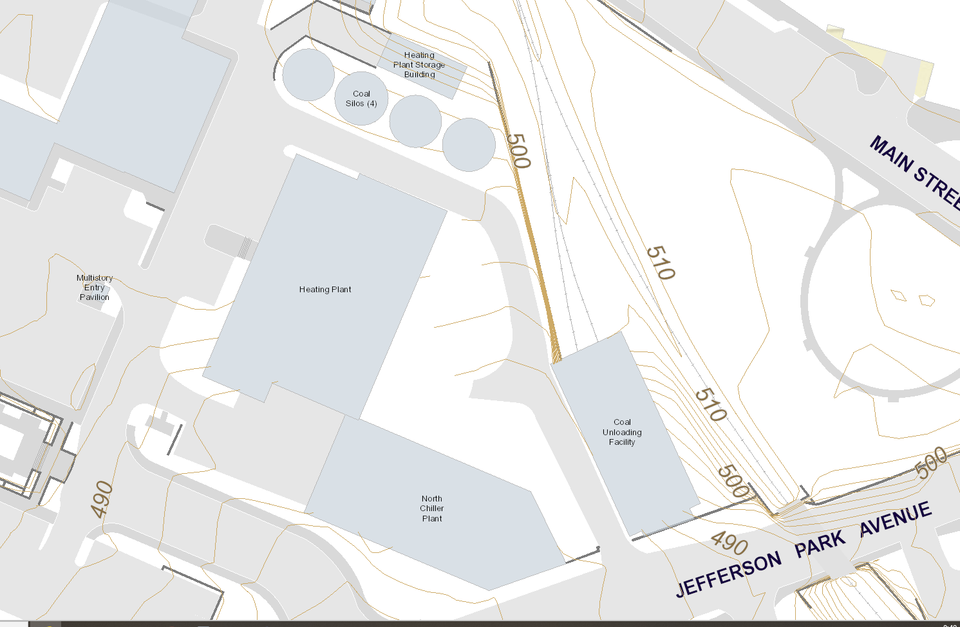
Thermal Storage Tank
Figure 1: Facility Topographic Location Map

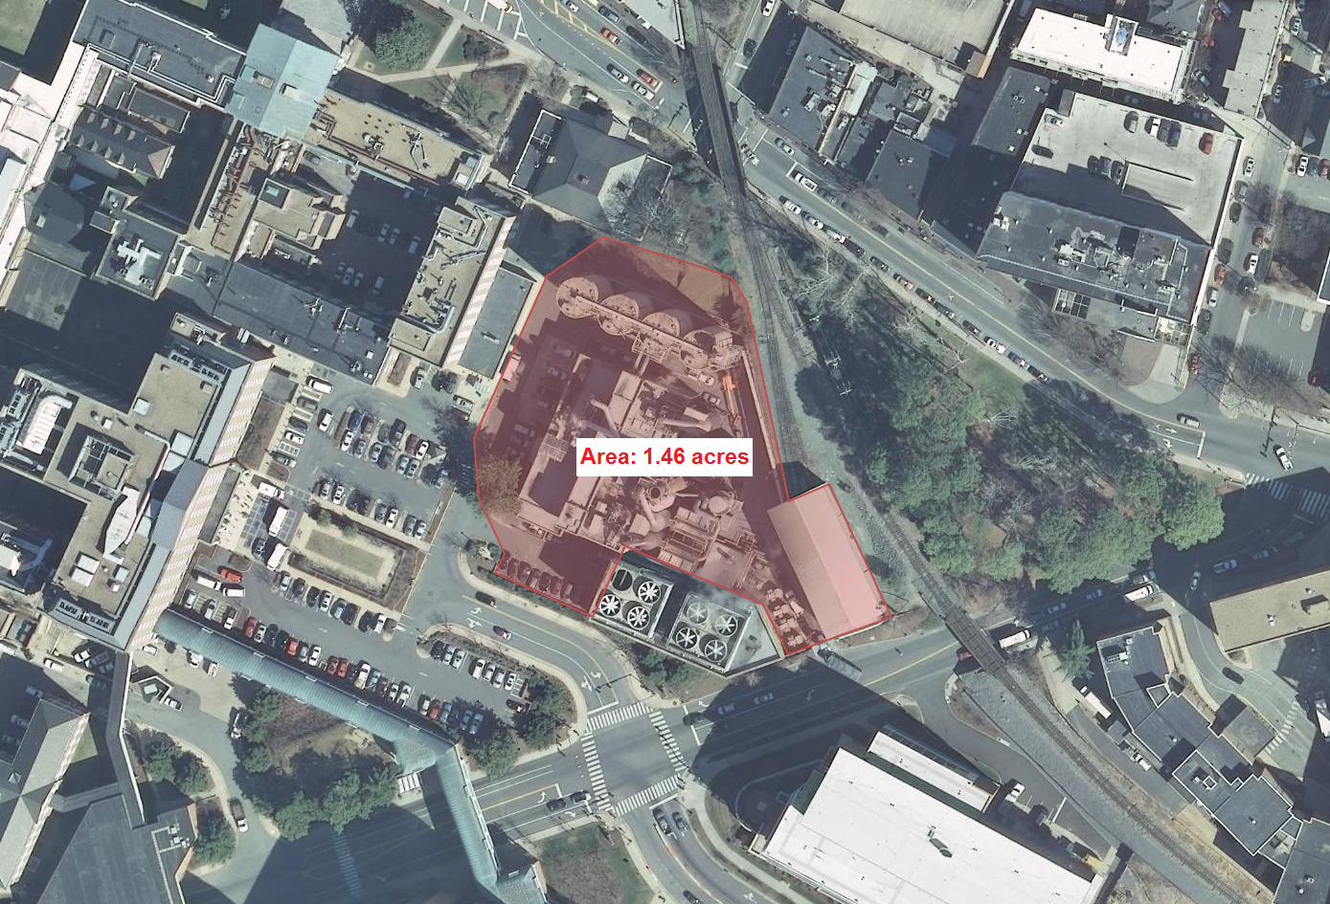
Figure 2: Aerial Photograph of Site and Vicinity

UVA operates the MHP to generate steam and hot water. These products are distributed through an underground utility pipe network to supply buildings on grounds for heating purposes. Heat is generated through the combustion of natural gas, ultra-low sulfur diesel (ULSD), and coal. Natural gas is directly piped to the plant by the City of Charlottesville. ULSD is delivered by truck and stored in four underground storage tanks (USTs) and two aboveground storage tanks (ASTs) on-site. The four USTs serve the boilers, one AST serves an emergency generator and the other AST is used for fueling offroad equipment such as forklifts. Coal is delivered by railcar. Railcar unloading occurs in a closed building with coal conveyed to four storage silos prior to conveyance into the main plant building for burning. Each coal boiler is equipped with a spray dry absorber (SDA) and baghouse for air pollution control. Lime is stored in a silo prior to being mixed into a slurry for injection into the SDAs for acid gas removal. Particulates generated during coal combustion and the salts formed in the SDAs are removed in the baghouses; this fly ash is conveyed and stored in a silo. Bottom ash (the unburned material in the coal) is conveyed to a silo. Ash is unloaded by truck for off-site disposal or recycling. This facility operates and remains staffed at all times.

The MHP is directly adjacent to the North Chiller Plant. Aside from the thermal storage tank located immediately west of the North Chiller Plant, all chiller plant equipment is located indoors. None of the indoor chiller plant activities are at risk of impacting stormwater.

2.3 Facility Stormwater Drainage System
Surface runoff from the site generally flows from north to south until intercepted by catch basins and drop inlets as indicated in Figure 3. The University’s MS4 connects to the City of Charlottesville’s MS4 at points 4 and 5. The City’s MS4 discharges stormwater to a tributary of Moores Creek, which is considered an “impaired” waterway for sediment by the Virginia Department of Environmental Quality (DEQ).

Most runoff that may potentially carry contaminants from the site flows to the trench drain at point 1 and/or ultimately flows to the catch basin at point 2, where water is temporarily intercepted by an inflatable bladder. Stormwater is contained here for observation before it is allowed to pass on to the rest of the storm sewer system.
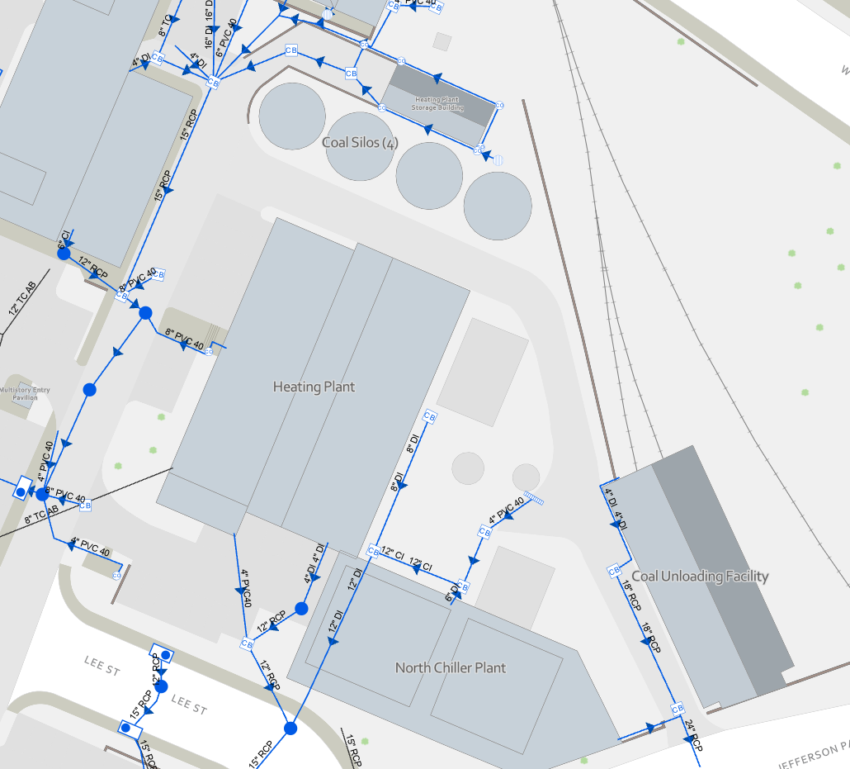
3
5
1
4
2
Figure 3. Facility Stormwater Drainage System

3.0 IDENTIFICATION OF POTENTIAL STORMWATER CONTAMINANTS
This section identifies significant materials located at the high-priority facility that may potentially contaminate stormwater and identifies potential areas for stormwater contamination. Potential non-stormwater sources are also described.

3.1 Potential Pollutants and Pollutant Sources
Materials used by the facility that have the potential to be pollutants are listed in Table 1. This table includes the material description, the source of the potential pollutant, its location, and potential risk.
Spills or fugitive dust from storage and handling of coal and ash can contribute to elevated concentrations in stormwater of total suspended solids (TSS), a pollutant associated with impairments in Moores Creek, the Rivanna River and the Chesapeake Bay. Runoff that contacts lime products will become basic (high pH), which is harmful to aquatic life in the creeks downstream of the MHP. Figure 4 identifies the location of all activities and materials that are exposed to precipitation or surface runoff and may impact stormwater quality.

3.2 Potential Nonstormwater Discharges
Table 2 below, identifies all nonstormwater discharges as authorized in the general permit that are or could be comingled with stormwater discharges from the high-priority facility, including any applicable support activity.

Table 1. Checklist of Potential Pollutants and Sources*
Material/Pollutant | Pollutant Source | Location of Pollutant | Potential Risk and Mitigation
Coal, coal dust | Railroad delivery, screen and crusher, fugitive dust emissions | Coal unloading facility | Low risk – building doors must be closed during operation and crusher vents to filter
Coal, coal dust | Conveyance, Storage | Conveyors, elevators, storage silos, bunkers | Low risk – conveyance system is fully enclosed or vented thru filters
Bottom ash | Ash unloading; fugitive dust emissions | Ash unloading area below bottom ash silo | Medium risk – loaded frequently, outdoors
Fly ash | Ash unloading; fugitive dust emissions | Ash unloading area below fly ash silo, under SDAs and baghouses | Medium risk – loaded frequently, outdoors, water sprays are used to minimize fugitive dust
Pebble Quicklime | Delivery vehicle | Lime Silo | Low risk – outdoor transfer, truck pumps quicklime up to silo via pressure, silo filter is inspected during use
Lime slurry | Spill, leaky equipment | Lime mixing tank, around slurry transfer lines | Medium risk – leaks/spills can reach storm sewer
Lime grit | Spill | Conveyor, storage shed for dumpster | Medium risk – leaks/overflows can reach storm sewer
Process water contaminated with lime | Spill | Process water tank and associated transfer lines | Low risk – covered tank with high level sensor and alarm
Diesel fuel | Delivery, spill, leaking tank | Stand-alone aboveground tank for generator | Medium risk – infrequent deliveries, outdoors, tank monitored continuously
Diesel fuel | Delivery, spill, leaking tank | Underground tanks | Medium risk – infrequent deliveries, fuel stored underground, tanks monitored continuously
Diesel fuel | Delivery, spill, leaking tank | Stand-alone aboveground tank for equipment fueling | Medium risk – tank fill port is located outdoors
Process chemicals, housekeeping supplies, oil/grease for equipment maintenance | Delivery vehicle | Doorways into plant buildings | Low risk – materials stored indoors
Equipment and vehicles | Leak | Parking areas, drive aisles and loading areas | Medium risk –Vehicles kept in good repair and receive routine maintenance to minimize risk of leaks
Designated ash/process waste dumpsters and hoppers | Leak | Throughout the property, near baghouses and SDAs | Medium risk –hoppers and dumpsters are typically covered or stored under cover, area drains to storm sewers
Chemically treated water | Leak | Thermal Storage Tank | Low risk – covered tank with no exterior fill/discharge port
*Rather than utilize a traditional checklist to indicate presence or absence of potential risks, this checklist directly identifies pollutants, sources, locations, and the known potential risk.

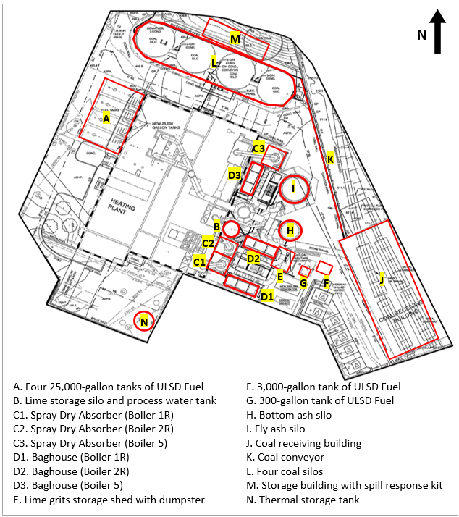
Figure 4: Locations at MHP that are Relevant to Stormwater Quality
Table 2. Potential Nonstormwater Discharges
Authorized Nonstormwater Discharges that could be Commingled with Stormwater Discharges at this Facility | Anticipated?
a. Water line flushing, managed in a manner to avoid an instream impact | Yes No
b. Landscape irrigation | Yes No
c. Diverted stream flows | Yes No
d. Rising groundwaters | Yes No
e. Uncontaminated groundwater infiltration, as defined at 40 CFR 35.2005(20) | Yes No
f. Uncontaminated pumped groundwater | Yes No
g. Discharges from potable water sources managed in a manner to avoid instream impact | Yes No
h. Foundation drains | Yes No
i. Air conditioning condensation | Yes No
j. Irrigation water | Yes No
k. Springs | Yes No
l. Water from crawl space pumps | Yes No
m. Footing drains | Yes No
n. Lawn watering | Yes No
o. Individual residential car washing | Yes No
p. Flows from riparian habitats and wetlands | Yes No
q. Dechlorinated freshwater swimming pool discharges managed in a manner to avoid instream impact | Yes No
r. Street and pavement wash waters that do not contain cleaning additives or are otherwise managed in a manner to avoid instream impact | Yes No
s. Routine external building washdown provided no soaps, solvents, or detergents are used, external building surfaces do not contain hazardous substances, and the wash water is filtered, settled, or similarly treated prior to discharge | Yes No
t. Discharges or flows from emergency firefighting activities | Yes No
u. Discharges or flows of water for fire prevention or firefighting training activities managed in a manner to avoid instream impact in accordance with § 9.1-207.1 of the Code of Virginia | Yes No
v. Discharges from noncommercial fundraising car washes if the washing uses only biodegradable, phosphate-free, water-based cleaners in accordance with § 15.2-2114.1 of the Code of Virginia | Yes No
w. Other activities generating discharges identified by the department as not requiring VPDES authorization | Yes No

4.0 POLLUTION PREVENTION, GOOD HOUSEKEEPING PRACTICES, AND STRUCTURAL CONTROL MEASURES
Each UVA facility that has been identified as a high-priority facility and conducts any of the activities listed in Section 4.2 that are expected to have exposure to stormwater must develop and implement a site specific written SWPPP designed to reduce and prevent pollutant discharge.

4.1 Site-Specific Operations
Site-specific Standard Operating Procedures (SOPs) and protocols have been established for daily operations at the MHP that are designed to minimize pollutant discharge to the storm sewer system. A general discussion of the SOPs is found below with copies available on the MHP network. UVA SOPs applicable to the MHP site are addressed in Sections 4.2 and 4.3 and listed in Appendix A.

4.1.1 Diesel Handling
ULSD is delivered by truck and stored on-site in four underground storage tanks (USTs) and two aboveground storage tanks (ASTs). The four USTs are connected to the boilers via underground piping. One AST serves the emergency generator, and the other is used for equipment fueling.

The fuel storage tanks will be maintained in good working order as required by the applicable State and Federal Regulations governing petroleum storage tanks and UVA’s Spill Prevention, Control and Countermeasures (SPCC) Plan. Spill and overfill prevention devices will be checked monthly to ensure that they are operational. The spill prevention device will be checked to ensure that it is free of fuel, water, and debris. If it is not, it will be cleaned out. Fuel will be drained into the tank, and water or debris will be removed for proper disposal. The Veeder Root leak detection system will be maintained and monitored for proper operation.

4.1.2 Coal Handling
Coal is delivered to the site by railcar. Railcar unloading occurs within a closed building with coal stored in one of four storage silos or bunkers, each equipped with cartridge filters for particulate control. Coal is moved around the plant using completely enclosed conveyance systems. These controls are all required by air permit and are inspected on a weekly basis when in use.

The Coal Handling SOP provides best practices for operating the conveyance systems and implementing the other controls, as well as for monitoring and responding to the various coal handling system alarms.

4.1.3 Quick Lime Truck Unloading
Pebble quicklime is delivered by truck and pumped in a closed pipe to the top of the lime silo. Particulate emissions from filling the silo are controlled by a baghouse, which is inspected during quicklime unloading operations. A Quick Lime Truck Unloading SOP has been developed to establish best management practices for this activity.

4.1.4 Lime Slurry Handling
Pebble quicklime is mixed with water to make a slurry that is used in the SDAs to treat boiler emissions. Slaking and slurry storage operations are housed within the lime silo shell. Slurry is recirculated through pipes and hoses between the storage tank and the SDA penthouses for injection.

At the end of the coal burning season and occasionally during it, the lime slurry system is rinsed. This rinse water and any wash water used to clean the lime silo and SDA penthouses is stored in the process water tank. Due to its high pH, this wastewater cannot be discharged to the sanitary sewer. Instead, it is used for dust control during ash unloading operations, hauled directly to the Moores Creek Advanced Water Resource Recovery Facility or disposed of by a private contractor.

4.1.5 Lime Grits Handling
During the slaking process, a byproduct of unreacted limestone, referred to as lime grits, is generated. Grits are screened out of the slurry and transferred from the lime silo by covered screw conveyor to a dumpster where they are dewatered. The collected water is pumped back to the grit screen and slurry tank in the lime silo. Grits are disposed with the fly ash, which is hauled away about three to five times a week during coal fire operations. The secondary containment chamber is emptied at the end of the coal burning season.

The lime grits dumpster is housed in a storage shed equipped with secondary containment. The shed door is kept closed to keep out precipitation except when open for unloading operations. Regular inspection of the lime grits handling process is conducted as part of the daily rounds. MHP staff follow the Clean Grit Screens SOP for best management practices related to lime grits handling.

4.1.6 Ash Silo Unloading
Bottom ash is the non-combustible material in the coal that remains after passing through the boiler. Particulates generated during coal combustion and the salts formed in the SDAs are removed in the baghouses and are referred to as fly ash. Ash is moved in completely enclosed conveyance systems to silos equipped with cartridge filters for particulate control. The cartridge filters are required by air permit and are inspected on a weekly basis when in use. While there is a silo designated separately for fly ash and bottom ash, both silos can accept either type of ash.

MHP staff follow the Fly Ash Silo Unloading Process and Bottom Ash Silo Unloading Process SOPs. Ash is wetted with liquids from the process water tank and/or City water as it is unloaded into trucks to minimize fugitive dust emissions. Any material on the ground should be swept and vacuumed up and disposed of in the ash truck. Fly ash is currently used as landfill beneficial cover, and bottom ash is used for making cement.

4.1.7 Stormwater Runoff Checks
An inflatable bladder is inserted into a storm pipe at the MHP that collects runoff from the pavement under and around the MHP air pollution controls systems, lime silos, and ash silos where residual spilled materials or settled fugitive dust could wash off during rain events. This bladder provides containment to evaluate the collected stormwater runoff for contamination prior to discharge and to capture potential dry weather spills. Regular inspection of the inflatable bladder is conducted as part of the daily rounds. If there is a spill or contamination is suspected, the storm manhole contents can be pumped to the process water tank. The MHP Storm Drain SOP provides more detail on this process.

4.2 Written Procedures for Operations and Maintenance Activities
UVA has developed procedures to reduce and prevent pollutant discharge on the site where potential contaminates may be washed into stormwater channels, sewer systems, or ground water. If a procedure is not relevant to the location, a comment has been entered that explains why this procedure is not applicable. In addition to the items noted below, UVA has developed a list of Standard Operating Procedures covering many operations and maintenance activities. The pertinent SOPs to this high-priority facility are listed in Appendix A and referred to below where applicable. All listed SOPs are available online at the Environmental Resources SOP website.

4.2.1 Prevent illicit discharges:
An illicit discharge as defined in 9VAC25-875-850 “means any discharge to a municipal separate storm sewer that is not composed entirely of stormwater, except discharges pursuant to a separate VPDES or permit (other than the permit for discharges from the municipal separate storm sewer), discharges resulting from firefighting activities, and discharges identified by and in compliance with 9VAC25-875-970 D.2.c(3).” MHP staff will maintain clean pavement, keep materials inside or under cover, and contain and report spills that may discharge into the MS4. UVA has an SOP to identify and report illicit discharges, as well as many SOPs that focus on preventing illicit discharges. UVA also has developed a program for spill response, including a spill response SOP, to try to prevent illicit discharges from occurring.

4.2.2 Ensure staff or contractors properly dispose of waste materials, including landscape wastes and prevent waste materials from entering the MS4:
Process wastes such as lime grits and ash in the storage silos are managed as described in Sections 4.1.5 and 4.1.6. Other small dumpsters and hoppers are located throughout the site for collection of waste products, such as wet ash from the SDAs. These dumpsters/hoppers should be:
- stored inside the building,
- stored in outdoor areas protected from rainfall (e.g., under the air pollution control equipment), or
- covered by a tarp or lid when not in active use.
Receptacles containing ash are emptied into the trucks used to unload the silos.

Any organic, non-toxic landscaping wastes generated from the site will be sent to the vegetative debris collection site located on Observatory Hill. UVA has developed SOPs to ensure the proper disposal of waste materials including an SOP on Waste Management and one on Landscape Materials and Organic Waste.

4.2.3 Prevent the discharge of wastewater or wash water not listed as an allowable nonstormwater discharge (Table 2) into the MS4 without authorization under a separate VPDES permit:
Process wastewater generated from the lime slurry system is managed as described in Section 4.1.4. The pavement under and around the MHP air pollution controls systems, lime silos, and ash silos is infrequently power washed to remove persistent residual materials. This work is performed in compliance with UVA’s SOP on Exterior Surfaces Washing. This washing operation is typically performed in the spring or summer after coal fire operations are done for the winter.

Facilities Management (FM) fleet vehicles (including those assigned to the MHP) are washed at the FM Yard vehicle wash area which drains to the sanitary sewer. UVA has developed an SOP on FM Yard Vehicle and Equipment Wash Locations.

4.2.4 Minimize the pollutants in stormwater runoff:
Bulk storage of diesel, coal, ash and lime is done using tanks and silos to minimize the likelihood of these materials coming into contact with stormwater runoff. Waste containers are covered or otherwise protected from precipitation.

4.2.5 Implement best management practices related to road, street, sidewalk, and parking lot maintenance and cleaning.
UVA has developed an SOP on Road, Street, Sidewalk, and Parking Lot Maintenance, Cleaning, and Anti-Icing and Deicing Application, Transport, and Storage (abbreviated “Road and Sidewalk Maintenance, Cleaning, and Deicing”). Use of agents containing urea or other forms of nitrogen or phosphorus is not permitted.

4.2.6 Implement best management practices related to renovation and significant exterior maintenance activities (e.g., painting, roof resealing, and HVAC coil cleaning) not covered under a separate VSMP construction general permit.
UVA has developed an SOP on Renovation and Significant Exterior Maintenance Activities that covers the required activities. UVA has also developed an SOP on Exterior Surfaces Washing which applies to washing of any building surfaces and equipment such as exterior HVAC equipment.

4.2.7 Require implementation of best management practices when discharging water pumped from construction and maintenance activities not covered by another permit covering such activities:
No water from construction and maintenance activities are discharged at this site under normal operations. If the MHP has construction activity that involves the discharge of pumped water, UVA staff or contractors involved will follow the SOP on Water Disposal from Dewatering Activities.

4.2.8 Implement best management practices related to the temporary storage of landscaping materials.
Landscaping materials are not stored at this site.

4.2.9 Maintenance of owned and operated vehicles and equipment to prevent pollutant discharge into the MS4 from leaking vehicles and equipment:
The FM Fleet Team administers the assignment, safe utilization, maintenance, repair and replacement of fleet vehicles and equipment. FM Fleet vehicles are subject to routine preventative maintenance. The employees of FM who notice any fleet vehicles that are leaking shall report these to the Fleet Manager so that repairs can be made as soon as possible. These vehicles will be taken for maintenance repairs, and any spills will be cleaned up following the procedures described in the Spill Response SOP. UVA has developed an SOP on Vehicle and Equipment Maintenance.

4.2.10 Ensure that the application of materials, including pesticides and herbicides, shall not exceed manufacturer’s recommendations. Application of fertilizer shall not exceed maximum application rates established by applicable nutrient management plans.
UVA has multiple Nutrient Management Plans to moderate the use of fertilizer on all state-owned lawn and landscape areas. Yearly inspections of records and licenses are conducted to ensure compliance with the Plans. Certified Applicators of pesticides or fertilizers must be re-certified every two years. For those who are not certified to apply pesticides or fertilizers, they must be trained and supervised by a Certified Applicator. UVA has developed an SOP on Pesticides, Herbicides and Fertilizers.

4.3 Written Procedures for High-Priority Facility Activities
This section addresses the procedures UVA will follow to prevent pollutants from entering the MS4 from the following common activities that occur at high-priority facilities and are expected to have exposure to stormwater. The following items address the methods that will be used at the high-priority location to prevent pollutants from entering the MS4. If an item is not relevant to the MHP, a comment has been entered that explains why this procedure is not applicable.

4.3.1 Areas where residuals from using, storing or cleaning machinery or equipment remain and are exposed to stormwater:
Most process chemicals and equipment, including those listed in Table 1, are stored inside the MHP building so they are not exposed to stormwater. No cleaning or washing of machinery or equipment will occur outside at this location.

4.3.2 Materials or residuals on the ground or in stormwater inlets from spills or leaks:
Bulk storage of diesel, coal, ash and lime is done using tanks and silos to minimize the likelihood of these materials coming into contact with stormwater runoff. All particulate residuals shall be swept up and disposed of into appropriate waste containers. Staff follow the MHP Storm Drain SOP described in Section 4.1.7 to manage stormwater runoff that may have picked up spilled or leaked material. Vehicles and equipment are kept in good repair as described in the Vehicle and Equipment Maintenance SOP. Fluid leaks will be handled according to the specific procedures described in the UVA Spill Response SOP.

4.3.3 Material handling equipment (except adequately maintained vehicles):
Lime, coal and ash conveyance equipment and diesel piping are closed systems with no exposure of materials to stormwater runoff.

Material handling equipment such as forklifts are checked before every use by certified forklift operators. Part of their inspection includes observation for any mechanical problems that may be apparent. If a leak is detected, a temporary drip pain may be used so that liquids can be easily cleaned up until the equipment can be repaired or the equipment is taken out of service until repairs are completed. Material handling equipment is kept in good condition as described in the Vehicle and Equipment Maintenance SOP.

4.3.4 Materials or products that would be expected to be mobilized in stormwater runoff during loading or unloading or transporting activities (e.g., rock, salt, fill dirt):
Loading, unloading and transporting of diesel, lime, coal and ash are conducted as described in Section 4.1 and the corresponding SOPs.

4.3.5 Materials or products stored outdoors (except final products intended for outside use where exposure to stormwater does not result in the discharge of pollutants):
MHP staff limit materials or products from being stored outside except on a temporary basis until they can be moved to their covered or indoor storage areas.

4.3.6 Materials or products that would be expected to be mobilized in stormwater runoff contained in open, deteriorated or leaking storage drums, barrels, tanks, and similar containers:
Any drums, barrels, and containers with materials or products are maintained in good condition and are stored inside the MHP building so they are not exposed to stormwater. Petroleum storage tanks with a capacity of 55 gallons or more are inspected monthly to verify they are in good condition and not leaking.

4.3.7 Waste material except waste in covered, non-leaking containers (e.g., dumpsters):
All waste materials will be disposed of into covered dumpsters or containers. As mentioned in section 4.2.2, UVA has developed SOPs to ensure the proper disposal of waste materials including an SOP on Waste Management, on the UVA Recycling Sorting Facility, and on Landscape Materials and Organic Waste.

4.3.8 Application or disposal of process wastewater (unless otherwise permitted):
Wastewater from lime slurry processes is managed in accordance with the procedures and SOPs described in Sections 4.1.4 and 4.1.6.

4.3.9 Particulate matter or visible deposits of residuals from roof stacks, vents or both not otherwise regulated (i.e., under an air quality control permit) and evident in the stormwater runoff:
No particulate matter from roof stacks or vents is evident in stormwater runoff from this facility.

4.4 Structural Control Measures
Stormwater runoff may potentially carry contaminants such as ash and lime into the storm sewer. An inflatable bladder or storm drain bag is inserted into the pipe exiting the catch basin (shown as point 2 in Figure 3). When properly inflated, the storm drain bag will keep spills or contaminated runoff from leaving the MHP site. An SOP regarding proper use of the storm drain bag is provided on the MHP network.

5.0 EMPLOYEE TRAINING
Training for employees at this high-priority facility whose job duties have the potential to impact the environment will be conducted at the frequency described in the employee training plan developed as part of the MS4 Program Plan. Training topics may include the recognition and reporting of illicit discharges; good housekeeping and pollution prevention practices; proper material handling; disposal and control of waste; container filling and transfer; proper storage; washing; and inspection procedures; site-specific information contained in the SWPPP; and any associated SOPs that apply to the facility. Employees working in and around this high-priority facility also receive periodic training, even if their job duties are not considered impactful.

Documentation on each training event includes the date, the number of employees attending the training, and the objective must be kept for a period of three years after each training event.

6.0 FACILITY INSPECTIONS AND PREVENTATIVE MAINTENANCE PLAN

6.1 Annual Inspections
An Annual Comprehensive Site Compliance Evaluation, using the Checklist found in Appendix B, will be completed approximately one year following the implementation of this SWPPP and annually thereafter. A member of the Environmental Resources team, or a designee, will perform this inspection. The evaluation shall include areas where: pollutants could have come into contact with stormwater, leaks or spills occurred from equipment in the past three years, off site tracking of pollutants may occur where vehicles enter and exit the site, the tracking or blowing of materials may occur, and areas where there is evidence of or the potential for pollutants entering the drainage system, and evidence of pollutants discharging to surface waters at facility outfalls. The evaluation shall include a review of training, maintenance performed, and effective operation of stormwater best management practices (BMPs). The inspector will determine if the BMPs are being properly maintained and are effective in reducing stormwater contamination. During the evaluation, the outfalls will also be inspected for the presence of unauthorized stormwater discharges. Any noncompliance issues observed will be documented in the report and appropriate staff will be notified to resolve the issues. If the facility is found to be compliant, the signed report will state that no issues were found. Findings are included in Appendix C.

6.2 Preventative Maintenance
As previously discussed in section 4.1.7, there is one site specific source control at this facility, which is an inflatable bladder used to reduce the risk of pollutant discharge to the MS4. This bladder is on an annual preventative maintenance schedule.

6.3 Changes to Site Operations
During the annual comprehensive site compliance evaluation, the inspectors will also determine if site operations have changed since development of this SWPPP. If operational changes have been made, the SWPPP Team will determine if those changes will impact stormwater quality and if there is a need to develop new BMPs, SOPs, or update the SWPPP to address the change. All operational changes and new BMPs will be recorded in this SWPPP in Appendix D. SOP updates that are completed as a result of site operational changes will be recorded in Appendix D and referenced in the SWPPP where applicable. Additionally, the inspection date, the inspection personnel, the scope of the inspection, major observations, and any needed revisions will be recorded. Revisions to the plan will occur within thirty days after the inspection that identifies the need for revisions.

7.0 NOTICE OF PLANNED CHANGES
If the facility expands, experiences any significant production increases or process modifications, or changes any significant material handling or storage practices which could impact stormwater, the SWPPP will be amended appropriately. The amended SWPPP will have a description of the new activities that contribute to the increased pollutant loading and planned source control activities. The SWPPP will also be amended if the state or federal compliance inspection officer determines that it is ineffective in controlling stormwater pollutants discharged to waters.

Notice of the planned changes to the Department of Environmental Quality is only required when any alteration or addition to a building, structure, facility or installation meets the criteria of a new source, significantly changes the nature or increases the quantity of pollutants discharged, or the changes may result in noncompliance with state permit requirements.

8.0 RECORD RETENTION REQUIREMENTS
Records described in the SWPPP must be retained on site for 3 years beyond the date of the report or monitoring record and shall be made available to the state or federal compliance inspection officer upon request. Additionally, employee training records, monitoring reports, and compliance evaluations shall also be maintained.

Each unauthorized discharge, release, or spill will be documented as part of the MS4 Permit and are tracked in the “IDDE and Spill Tracking” spreadsheet for the applicable MS4 Permit cycle. Instead of creating a separate log of these incidents in this SWPPP, the “IDDE and Spill Tracking” spreadsheet is incorporated by reference into this document to serve the purpose to provide the required “log of unauthorized discharge, release, or spill incident.” For tracking purposes, facility staff should be sure to report all spills to ER, even if additional response efforts are not needed. This SWPPP and any applicable SOP will be reviewed after each incident to determine if any updates are needed. The IDDE and Spill Tracking spreadsheet documents whether or not a SWPPP update is needed. Updates will be documented in SWPPP Appendix D as needed.

Appendix A

Standard Operating Procedures for the Main Heating Plant

Main Heating Plant Standard Operating Procedures
Site-Specific SOPs:
- Coal Handling
- Lime Unloading Process
- Slaker Start Up - Shut Down
- Seasonal Slaker Changes
- Penthouse Spray Dryer Start Up
- Penthouse Spray Dryer Shut Down
- Spray Dryer Operational Checks
- Clean Grit Screens
- Bottom Ash Silo Unloading Process
- Fly Ash Silo Unloading Process
- Weekly Fugitive Dust inspection
- MHP Storm Drain Procedure
The most recent versions of these SOPs are available in the Heat Plant Admin Operating Procedures folder on the FM network.
Generic UVA SOPs Applicable to the MHP:
- Exterior Surfaces Washing
- FM Yard Vehicle and Equipment Wash Locations
- Illicit Discharge Detection
- Landscape Materials and Organic Waste
- Pesticides, Herbicides, and Fertilizers
- Renovation and Significant Exterior Maintenance Activities
- Road and Sidewalk Maintenance, Cleaning, and Deicing
- Spill Response
- Used Oil Disposal
- UVA Recycling Sorting Facility
- Vehicle and Equipment Maintenance
- Waste Management
- Water Disposal from Dewatering Activities
The most recent versions of these SOPs can be found at the Environmental Resources Website.

Appendix B

Annual Comprehensive Site Compliance Evaluation Checklist

Annual Comprehensive Site Compliance Evaluation Checklist (Page 1)
Date
Area Inspected: Main Heating Plant
Inspector’s Name and Title
Have any illicit discharges occurred since the last annual inspection?
Activity | Yes/No/NA | Corrective Actions and Dates
1. Vehicle entry and exit locations are free of off-site tracking of pollutants | Yes No NA
2. Parking and other paved areas free of signs of spills or leakage from vehicles or equipment. | Yes No NA
3. Site is free of trash or debris. | Yes No NA
4. Areas surrounding the silos, SDAs and baghouses are tidy and free of spills. | Yes No NA
5. Lime grits dumpster is properly positioned on the secondary containment system | Yes No NA
6. Dumpsters and hoppers are properly covered, if not in active use, or placed under cover to protect from rainwater. | Yes No NA
7. Dumpsters and hoppers are free of visible leaks. | Yes No NA
8. Areas surrounding the AST and UST fill ports are free of any signs of a diesel spill. | Yes No NA
9. Inflatable bladder (BMP) is operational. | Yes No NA
10. Non-stormwater discharges (e.g. wash water) properly controlled. | Yes No NA
11. Materials that are potential stormwater contaminants are stored inside or under cover. | Yes No NA
12. Materials are contained properly to prevent tracking and blowing. | Yes No NA
13. No evidence of, or potential for, pollutants entering the drainage system. A complete pollutant list is provided in Table 1. | Yes No NA
14. Stormwater outfalls free from unauthorized discharges. | Yes No NA
15. No obvious reoccurrence likely in areas where leaks or spills have occurred within the past 3 years. | Yes No NA
16. Any changes in drainage area conditions or site operations since the last inspection? | Yes No

Describe any incidents of non-compliance not described above and corrective actions taken:

Signature of Inspector___________________________________ Date: ___________________

Appendix C

Annual Inspection Reports

Appendix D

Log of Changes and Updates to SWPPP

Log of Changes and Updates to SWPPP for the Main Heating Plant

Date | Section and Description | Changes Reviewed By:
11/2018 | Updated SWPPP team members in Section 2.0, and phone numbers for spill response reporting in Section 6.5. | Kristin Carter
11/2018 | Revised training and inspection schedules in Sections 7.0 and 8.1 to be consistent with the MS4 Permit effective 11/01/18. | Kristin Carter
01/2022 | Consolidation of sections 2.0 and 3.4 into other sections, with subsequent renumbering. Updated sections 1.2, 4.1, and 4.2 for consistency with regulatory language. Included direct references to SOPs in sections 4.1 and 4.2 where applicable. Updated section 6.0 to refer to MS4 Program Plan for training frequency. Updated Appendix formatting. Re-ordered Appendices for consistency with order of appearance in document. Removed training sign in sheet from Appendix due to virtual training. Other updates language edits for clarity, consistency with other SWPPP language, and typo corrections. | Kristin Carter
7/2025 | Updated sections 1 and 4 to incorporate new regulatory language from the MS4 permit. Updated section 2, and Figure 4 map and lists of site activities in section 3, to reflect changes on the site. Updated direct references to SOPs in section 4.1 and updated the list of SOPs in Appendix A for consistency. Added section 4.4. Removed detailed spill response discussion to instead reference spill response SOP as appropriate. Removed mention of coal truck unloading and emergency stockpiling from section 4.1.2, for consistency with documentation that these activities no longer take place. Other updates include language edits for clarity, consistency with other SWPPP language, and typo corrections. | B. Olenslager
October 2026 | Remove reference to certified Nutrient Management Planner, Update SOP titles and add references to new SOPs. | J. Wenger

