

STORMWATER POLLUTION PREVENTION PLAN FOR
Recycling Sorting Facility
Date: August 1, 2016
MS4 Permit Number: VAR040073

Date of Most Recent Update:
September 25, 2026

Prepared by:

Environmental Resources

University of Virginia
P.O. Box 400726
Charlottesville, VA 22904-4726

TABLE OF CONTENTS

1.0 INTRODUCTION 4
1.1 Purpose 4
1.2 SWPPP Content 5
2.0 FACILITY INFORMATION 7
2.1 Facility Location 7
2.2 Facility Description and Activities 8
2.3 Facility Stormwater Drainage System 8
3.0 IDENTIFICATION OF POTENTIAL STORMWATER CONTAMINANTS 10
3.1 Potential Pollutants and Pollutant Sources 10
3.2 Potential Nonstormwater Discharges 10
4.0 POLLUTION PREVENTION, GOOD HOUSEKEEPING PRACTICES, AND STRUCTURAL CONTROL MEASURES 14
4.1 Written Procedures for Operations and Maintenance Activities 14
4.2 Written Procedures for High-Priority Facility Activities 17
4.3 Structural Control Measures 19
5.0 EMPLOYEE TRAINING 20
6.0 FACILITY INSPECTIONS AND PREVENTATIVE MAINTENANCE PLAN 21
6.1 Annual Inspections 21
6.2 Preventative Maintenance 21
6.3 Changes to Site Operations 21
7.0 NOTICE OF PLANNED CHANGES 23
8.0 RECORD RETENTION REQUIREMENTS 24
APPENDICES
Appendix A Standard Operating Procedures for this High-Priority Facility
Appendix B Annual Comprehensive Site Compliance Evaluation Checklist
Appendix C Annual Inspection Reports
Appendix D Log of Changes and Updates to SWPPP
CERTIFICATION
I certify that I have read and understand this document and that this document and all attachments were prepared in accordance with a system designed to assure that qualified personnel properly gathered and evaluated the information submitted. Based on my inquiry of the person or persons who manage the system or those persons directly responsible for gathering the information, the information submitted is to the best of my knowledge and belief true, accurate, and complete.

Authorized By: _Donald E. Sundgren______________
Title: _Vice President and Chief Facilities Officer___________________

A signed version of this document is available upon request by emailing storm-water@virginia.edu

Signature: ____________________________________ Date: _9/25/2026_________________

1.0 INTRODUCTION

1.1 Purpose
The University of Virginia (UVA) is subject to a General Permit for Discharges of Stormwater from Small Municipal Separate Storm Sewer Systems (MS4s). This permit requires that UVA identify high-priority locations requiring Stormwater Pollution Prevention Plans (SWPPP). These plans are designed to minimize or prevent pollutant discharge from daily operations such as road, street, and parking lot maintenance, equipment maintenance, and the application, storage, transport, and disposal of fuels, chemicals, pesticides, herbicides, and fertilizers.
UVA has developed this SWPPP to incorporate the requirements of the MS4 Permit. UVA must identify all high-priority facilities, which means facilities owned or operated by UVA with drainage to any permitted MS4 that actively engage in one or more of the following activities:
- Composting;
- Equipment storage, cleaning, and maintenance;
- Long term bulk materials storage;
- Pesticide, herbicide, and fertilizer storage;
- Recycling;
- Anti-icing and deicing agent storage, handling, and transfer;
- Solid waste handling and transfer; and
- Vehicle washing, maintenance, and salvage.
The primary goals of the SWPPP will be to:
- Identify potential sources of pollutants that affect stormwater discharges from this facility;
- Describe the practices that will be implemented to prevent or control the release of pollutants in stormwater discharges; and
- Create an implementation schedule to ensure that the practices described in this SWPPP are in fact implemented and to evaluate the plan’s effectiveness in reducing the pollutant levels in stormwater discharges.

1.2 SWPPP Content
This SWPPP includes the following:
- A site description that includes a site map identifying all outfalls, direction of stormwater flows, existing source controls, and receiving water bodies;
- A description and checklist of potential pollutants and pollutant sources;
- A description of all potential nonstormwater discharges;
- A description of all structural control measures, such as stormwater management facilities and other pollutant source controls, applicable to SWPPP implementation such as oil-water separators, and inlet protection designed to address potential pollutants and pollutant sources at risk of being discharged to the MS4;
- A maintenance schedule for all stormwater management facilities and other pollutant source controls applicable to SWPPP implementation as described in 1.2.f.
- Site specific written procedures designed to reduce and prevent pollutant discharge that incorporate by reference applicable good housekeeping procedures required by the permit;
- A description of the applicable training as required;
- An inspection frequency of no less than once per year and maintenance requirements for site specific source controls. The date of each inspection and associated findings and follow-up shall be logged in each SWPPP;
- A log of each unauthorized discharge, release, or spill incident reported in accordance with permit requirements including the date of incident; material discharged, released, or spilled; and estimated quantity discharged, released, or spilled;
- A log of modifications to the SWPPP made as the result of any unauthorized discharge, release, or spill in accordance with permit requirements or changes in facility activities and operation requiring SWPPP modification.
- The point of contact for SWPPP implementation.

2.0 FACILITY INFORMATION

2.1 Facility Location
Facility Name: Recycling Sorting Facility
Facility Address: 2456 Old Ivy Rd
Facility Acreage: 0.4 acres
University’s Primary SIC Code: 8221
Watershed this facility drains to? Meadow Creek
Moore’s Creek
Facility Point of Contact Kristin Carter: 434-982-5034, email Kristin

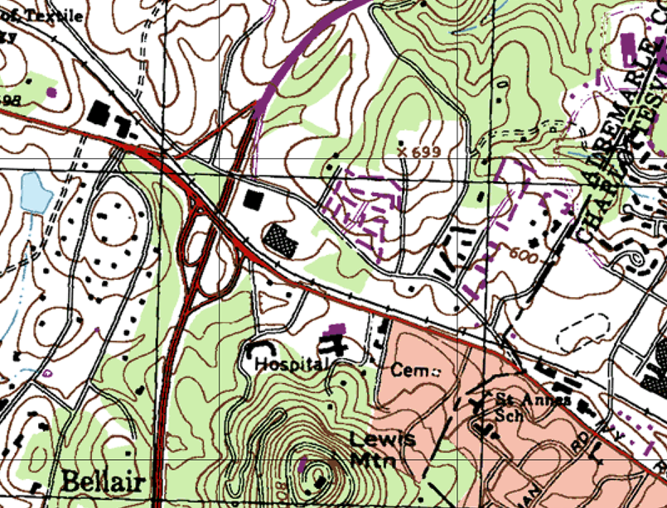
Site Location:
38.047871°N
-78.521631°W
Figure 1: USGS Topographic Location Map of Recycling Sorting Facility
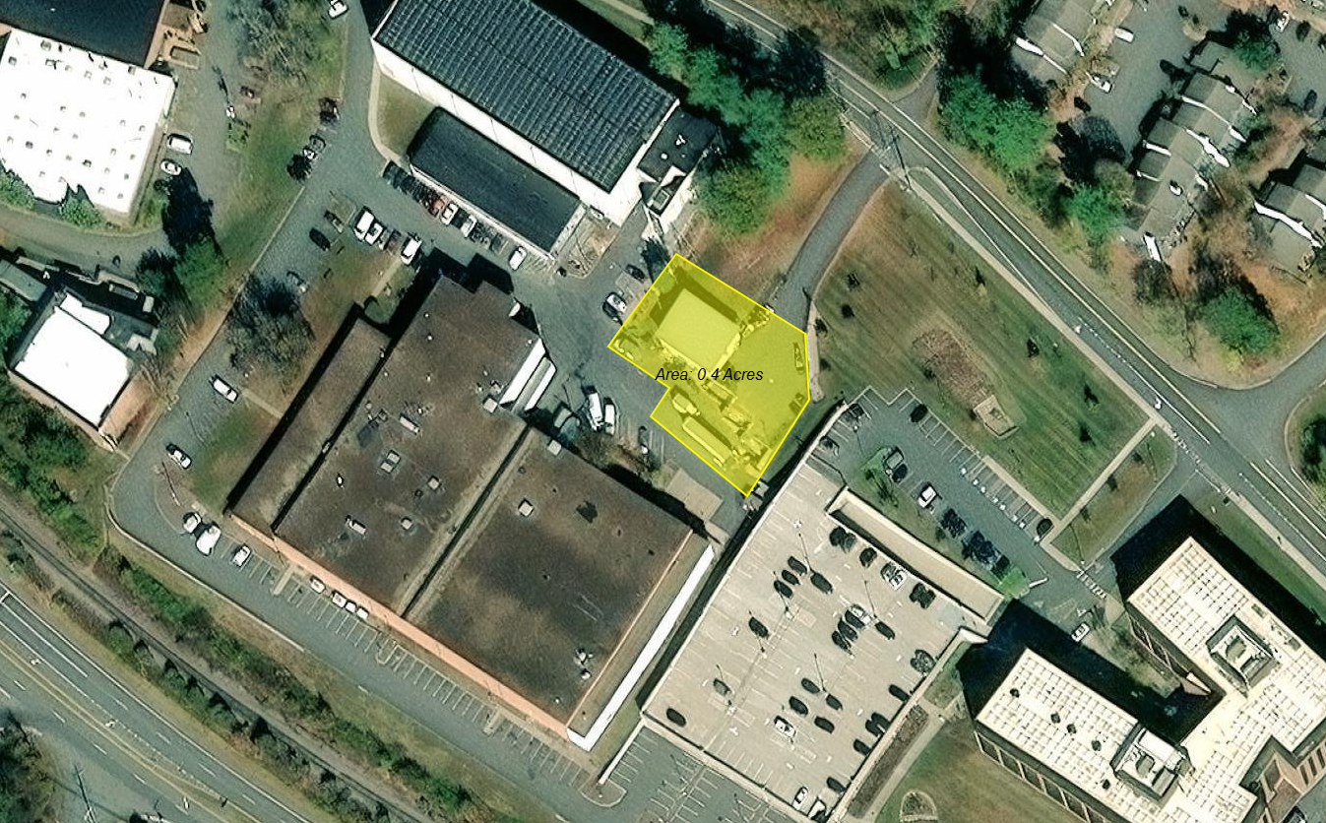
Figure 2: Aerial Photograph of Site and Vicinity

2.2 Facility Description and Activities
The total area of the site is approximately 0.4 acres, the majority of which is impervious consisting of pavement and buildings (Figures 1-2). The site consists of the sorting building, the materials storage dumpsters and containers, and the paved surfaces allowing access to the site.
The site’s principal activity is to house the UVA Recycling Sorting Facility. The Recycling Sorting Facility provides space for UVA trucks to unload recyclable materials solely generated from University activities. Materials are collected, separated, compacted and bailed prior to pick-up by outside waste vendors. Recycling dumpsters for glass, metals, and construction debris from interior renovations are stored on site.

2.3 Facility Stormwater Drainage System
Stormwater at the lower level of the recycling center and around the dumpsters flows into a storm drain, where it flows to a detention basin south of the Old Ivy Road Office Building for treatment. Stormwater that flows north of the recycle center at the elevation of the second level of the building flows into a separate storm drain network, where it flows to an underground detention chamber south of the Old Ivy Road Office Building. Both of these drainage networks are part of the University’s Municipal Separate Storm Sewer System (MS4). The MS4 in this area discharges stormwater into an unnamed tributary to Morey Creek, which is located across Ivy Road to the south of the site (Figure 3).
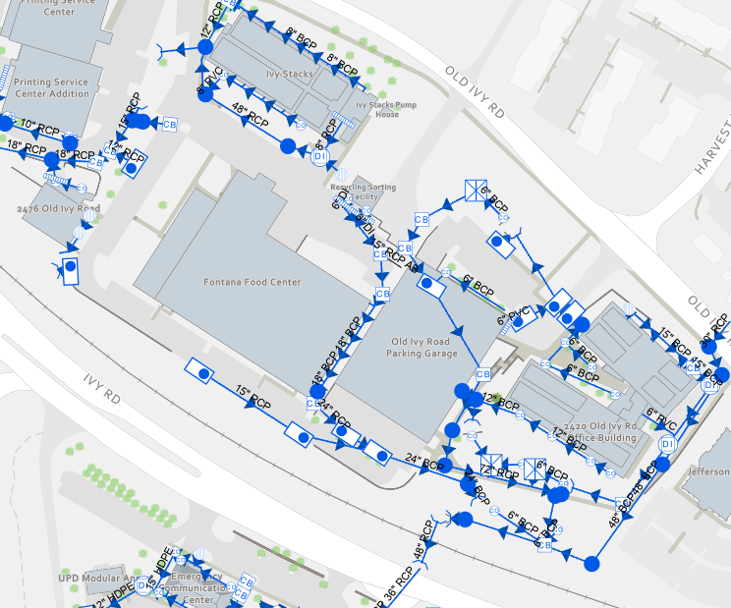Figure 3: Facility Stormwater Drainage System

3.0 IDENTIFICATION OF POTENTIAL STORMWATER CONTAMINANTS
This section identifies significant materials located at the high-priority facility that may potentially contaminate stormwater and locates areas where stormwater contamination may occur. Potential non-stormwater sources are also described.

3.1 Potential Pollutants and Pollutant Sources
Materials used by the facility that have the potential to be pollutants are listed in Table 1. This table includes the material description, the source of the potential pollutant, its location and potential risk.

3.2 Potential Nonstormwater Discharges
Table 2 identifies all nonstormwater discharges as authorized in the general permit that are or will be commingled with stormwater discharges from the high-priority facility, including any applicable support activity. Authorized nonstormwater discharges include:

Table 1. Checklist of Potential Pollutants and Sources*
Material/Pollutant | Pollutant Source | Location of Pollutant | Potential Risk
Recycled Scrap Metal, Glass | Handling, Storage | Sorting facility | Low – indoors or covered
Recycled Aluminum/steel cans, plastics, and paper | Handling, storage | Sorting facility | Low – indoors or covered
Recycling products | Seepage from sorting liquid containers | Sorting facility | Low – indoors and disposed of in sanitary sewer
Lube oil | Spill | Sorting facility | Low – lid containers
Chemicals | Spill | Sorting facility | Low – under cover
Equipment and vehicles | Leak | Surrounding building | Medium risk –Vehicles kept in good repair and receive routine maintenance to minimize risk of leaks
Gypsum board | Storage, spill | Construction and Demolition Debris (CDD) dumpster | Medium risk
Wood, metal, plastics | Storage, spill | CDD dumpster | Medium risk
Concrete, brick | Storage, spill | CDD dumpster | Medium risk
Insulating materials | Storage, spill | CDD dumpster | Medium risk
*Rather than utilize a traditional checklist to indicate presence or absence of potential risks, this checklist directly identifies pollutants, sources, locations, and the known potential risk.

Table 2. Potential Nonstormwater Discharges
Authorized Nonstormwater Discharges that could be Commingled with Stormwater Discharges at this Facility | Anticipated?
a. Water line flushing, managed in a manner to avoid an instream impact | Yes No
b. Landscape irrigation | Yes No
c. Diverted stream flows | Yes No
d. Rising groundwaters | Yes No
e. Uncontaminated groundwater infiltration, as defined at 40 CFR 35.2005(20) | Yes No
f. Uncontaminated pumped groundwater | Yes No
g. Discharges from potable water sources managed in a manner to avoid instream impact | Yes No
h. Foundation drains | Yes No
i. Air conditioning condensation | Yes No
j. Irrigation water | Yes No
k. Springs | Yes No
l. Water from crawl space pumps | Yes No
m. Footing drains | Yes No
n. Lawn watering | Yes No
o. Individual residential car washing | Yes No
p. Flows from riparian habitats and wetlands | Yes No
q. Dechlorinated freshwater swimming pool discharges managed in a manner to avoid instream impact | Yes No
r. Street and pavement wash waters that do not contain cleaning additives or are otherwise managed in a manner to avoid instream impact | Yes No
s. Routine external building washdown provided no soaps, solvents, or detergents are used, external building surfaces do not contain hazardous substances, and the wash water is filtered, settled, or similarly treated prior to discharge | Yes No
t. Discharges or flows from emergency firefighting activities | Yes No
u. Discharges or flows of water for fire prevention or firefighting training activities managed in a manner to avoid instream impact in accordance with § 9.1-207.1 of the Code of Virginia | Yes No
v. Discharges from noncommercial fundraising car washes if the washing uses only biodegradable, phosphate-free, water-based cleaners in accordance with § 15.2-2114.1 of the Code of Virginia | Yes No
w. Other activities generating discharges identified by the department as not requiring VPDES authorization | Yes No

4.0 POLLUTION PREVENTION, GOOD HOUSEKEEPING PRACTICES, AND STRUCTURAL CONTROL MEASURES
Each UVA facility that has been identified as a high-priority facility and conducts any of the activities listed in Section 4.2 that are expected to have exposure to stormwater must develop and implement site specific written SWPPP designed to reduce and prevent pollutant discharge.

4.1 Written Procedures for Operations and Maintenance Activities
UVA has developed procedures to reduce and prevent pollutant discharge on the site where potential contaminates may be washed into stormwater channels, sewer systems, or ground water. If a procedure is not relevant to the location, a comment has been entered that explains why this procedure is not applicable. In addition to the items noted below, UVA has developed a list of Standard Operating Procedures covering many operations and maintenance activities. The pertinent SOPs to this high-priority facility are listed in Appendix A and referred to below where applicable. All listed SOPs are available online at: https://pollutionprevention.virginia.edu/soppp/.
4.1.1 Prevent illicit discharges:
An illicit discharge as defined in 9VAC25-875-850 “means any discharge to a municipal separate storm sewer that is not composed entirely of stormwater, except discharges pursuant to a separate VPDES or permit (other than the permit for discharges from the municipal separate storm sewer), discharges resulting from firefighting activities, and discharges identified by and in compliance with 9VAC25-875-970 D.2.c(3).” Materials which could be subject to entering the storm system will be kept under covered, non-leaking containers. UVA has an SOP to identify and report illicit discharges, as well as many SOPs that focus on preventing illicit discharges. UVA also has developed a program for spill response, including a spill response SOP, to try to prevent illicit discharges before they occur.
4.1.2 Ensure staff or contractors properly dispose of waste materials, including landscape wastes and prevent waste materials from entering the MS4:
Wastes will be disposed of in appropriate covered dumpsters. UVA has developed an SOP on Waste Management. Landscape wastes are not generated at this facility. Floor and ground surfaces at all storage and work areas shall be maintained as appropriate. Floors shall be swept clean and garbage and waste material shall be disposed of on a regular basis. Waste material from containers (fluids and solids) and liquids generated during the processing of containers will be disposed of in the sanitary sewer via the floor drains interior to the building. All washing shall take place indoors at a sanitary sewer drain. No outdoor washing of waste materials or storage containers will be allowed. Additionally, UVA has developed an SOP on the UVA Recycling Sorting Facility to instruct facility users on what wastes can be accepted at the facility and how they should be managed on site.
4.1.3 Prevent the discharge of wastewater or wash water not listed as an allowable nonstormwater discharge (Table 2) into the MS4 without authorization under a separate VPDES permit:
As noted in section 4.1.2, outdoor washing is prohibited at this facility and wastewater disposal is limited to interior floor drains. Recycling vehicles are considered part of the FM Fleet and are washed at the FM Yard vehicle wash area according to the FM Yard Vehicle and Equipment Wash Locations SOP. UVA has also developed an SOP on Exterior Surfaces Washing.
4.1.4 Minimize the pollutants in stormwater runoff:
Potential pollutant sources noted in Table 1 are stored to avoid contact with stormwater runoff.
4.1.5 Implement best management practices related to road, street, sidewalk, and parking lot maintenance and cleaning.
UVA has developed an SOP on Road, Street, Sidewalk, and Parking Lot Maintenance, Cleaning, and Anti-Icing and Deicing Application, Transport, and Storage (abbreviated “Road and Sidewalk Maintenance, Cleaning, and Deicing”)Use of agents containing urea or other forms of nitrogen or phosphorus are not purchased.
4.1.6 Implement best management practices related to renovation and significant exterior maintenance activities (e.g., painting, roof resealing, and HVAC coil cleaning) not covered under a separate VSMP construction general permit.
UVA has developed an SOP on Renovation and Significant Exterior Maintenance Activities that covers the required activities. UVA has also developed an SOP on Exterior Surfaces Washing which applies to washing of any building surfaces and equipment such as exterior HVAC equipment.
4.1.7 Require implementation of best management practices when discharging water pumped from construction and maintenance activities not covered by another permit covering such activities:
No water from construction and maintenance activities are discharged at this site under normal operations. If the Recycle Sort Facility has construction activity that involves the discharge of pumped water, UVA staff or contractors involved will follow the SOP on Water Disposal from Dewatering Activities.
4.1.8 Implement best management practices related to the temporary storage of landscaping materials.
Landscaping materials are not stored at this site.
4.1.9 Maintenance of owned and operated vehicles and equipment to prevent pollutant discharge into the MS4 from leaking vehicles and equipment:
The FM Fleet Team administers the assignment, safe utilization, maintenance, repair and replacement of fleet vehicles and equipment. FM Fleet vehicles are subject to routine preventative maintenance. The employees of FM who notice any fleet vehicles that are leaking shall report these to the Fleet Manager so that repairs can be made as soon as possible. These vehicles will be taken for maintenance repairs and any spills will be cleaned up following the procedures described in the Spill Response SOP. UVA has developed an SOP on Vehicle and Equipment Maintenance.
4.1.10 Ensure that the application of materials, including pesticides and herbicides, shall not exceed manufacturer's recommendations. Application of fertilizer shall not exceed maximum application rates established by applicable nutrient management plans.
UVA has multiple Nutrient Management Plans to moderate the use of fertilizer on all state-owned lawn and landscape areas. Yearly inspections of records and licenses are conducted to ensure compliance with the Plans. Certified Applicators of pesticides or fertilizers must be re-certified every two years. For those who are not certified to apply pesticides or fertilizers, they must be trained and supervised by a Certified Applicator. UVA has developed an SOP on Pesticides, Herbicides and Fertilizers. It is not anticipated that pesticides, herbicides, or fertilizers will be used at this facility, nor are they stored on site.

4.2 Written Procedures for High-Priority Facility Activities
This section addresses the procedures UVA will follow to prevent pollutants from entering the MS4 from the following common activities that occur at high-priority facilities and are expected to have exposure to stormwater. The following items address the methods that will be used to prevent pollutants from entering the MS4. If an activity is not relevant to the Recycling Sorting Facility, a comment has been entered that explains why this procedure is not applicable.
4.2.1 Areas where residuals from using, storing or cleaning machinery or equipment remain and are exposed to stormwater:
No cleaning or washing of machinery or equipment will occur at this location. Tractors or trucks kept for material handling will be monitored for leaks and removed from this location if repairs are necessary.
4.2.2 Materials or residuals on the ground or in stormwater inlets from spills or leaks:
Bulk materials are not stored on site. Vehicles and equipment are kept in good repair as described in the Vehicle and Equipment Maintenance SOP. Fluid leaks will be handled according to the specific procedures described in the UVA Spill Response SOP.
4.2.3 Material handling equipment:
Material handling equipment such as forklifts are checked before every use by certified forklift operators. Part of their inspection includes observation for any mechanical problems that may be apparent. At this time, if the operator notices any leaks, the equipment would be taken out of service until repairs are completed. Material handling equipment is kept in good repair as described in the Vehicle and Equipment Maintenance SOP.
4.2.4 Materials or products that would be expected to be mobilized in stormwater runoff during loading or unloading or transporting activities (e.g., rock, salt, fill dirt):
No loading or unloading of bulk materials or products that would be expected to be mobilized in stormwater runoff is expected to occur at this site.
4.2.5 Materials or products stored outdoors (except final products intended for outside use where exposure to stormwater does not result in the discharge of pollutants):
All waste materials will be kept in covered, leak proof dumpsters at the Recycling facility. Each outdoor container for the collection of recyclables will be covered to reduce stormwater exposure. A cover will be placed over each container after operating hours and during rain events. Operators will prevent damage to covers and cover integrity will be observed daily and repaired or replaced as necessary. Snow and accumulating water will be removed from covers to prevent damage. The area outside of the recycling facility shall be monitored for loose waste material to ensure that there is none exposed outside of the facility. If temporary high inventory requires that materials be stored outdoors, materials will be stored on pallets and covered. UVA has developed an SOP on Waste Management as well as an SOP on the Recycling Sorting Facility.
4.2.6 Materials or products that would be expected to be mobilized in stormwater runoff contained in open, deteriorated or leaking storage drums, barrels, tanks, and similar containers:
Generally, materials contained in drums, barrels, tanks, or similar containers are not stored on site.
4.2.7 Waste material except waste in covered, non-leaking containers (e.g., dumpsters):
All waste materials will be stored in covered dumpsters or containers. Dumpsters will be covered and leak proof so that rainwater will not enter the container, and any liquids contained inside cannot contaminate runoff. Dumpsters found to have holes will be replaced. As noted in section 4.1.2, UVA has developed an SOP on Waste Management and on the Recycling Sorting Facility.
4.2.8 Application or disposal of process wastewater (unless otherwise permitted):
No process wastewater is generated from this site.
4.2.9 Particulate matter or visible deposits of residuals from roof stacks, vents or both not otherwise regulated (i.e., under an air quality control permit) and evident in the stormwater runoff:
No particulate matter from roof stacks is evident in stormwater runoff from this facility.

4.3 Structural Control Measures
There are no structural control measures located on site.

5.0 EMPLOYEE TRAINING
Training for employees at this high-priority facility whose job duties have the potential to impact the environment will be conducted at the frequency described in the employee training plan developed as part of the MS4 Program Plan. Training topics may include the recognition and reporting of illicit discharges, good housekeeping and pollution prevention practices, proper material handling, disposal and control of waste, container filling and transfer, proper storage, washing, and inspection procedures, site-specific information contained in the SWPPP, and any associated SOPs that apply to this facility.
Documentation on each training event including the date, the number of employees attending the training, and the objective must be kept for a period of three years after each training event.

6.0 FACILITY INSPECTIONS AND PREVENTATIVE MAINTENANCE PLAN

6.1 Annual Inspections
An Annual Comprehensive Site Compliance Evaluation, using the Checklist found in Appendix B, will be completed approximately one year following the implementation of this SWPPP and annually thereafter. A member of the Environmental Resources team, or a designee, will perform this inspection. The evaluation shall include areas where: pollutants could have come into contact with stormwater, leaks or spills occurred from equipment in the past three years, off site tracking of pollutants may occur where vehicles enter and exit the site, the tracking or blowing of materials may occur, and where there is evidence of or the potential for pollutants entering the drainage system, and evidence of pollutants discharging to surface waters at facility outfalls. The evaluation shall include a review of training, maintenance performed, and effective operation of stormwater best management practices (BMPs). The inspector will determine if the BMPs are being properly maintained and are effective in reducing stormwater contamination. During the evaluation, the outfalls will also be inspected for the presence of unauthorized stormwater discharges. Any noncompliance issues observed will be documented in the report and appropriate staff will be notified to resolve the issues. If the facility is found to be compliant, the signed report will state that no issues were found. Findings are included in Appendix C.

6.2 Preventative Maintenance
Site-specific source controls are required to be inspected and maintained on a routine basis. In most cases, these processes are managed through Facilities Management’s computerized maintenance management system, AiM. There are no site-specific source controls at this facility, so no preventative maintenance processes or procedures apply.

6.3 Changes to Site Operations
During the annual comprehensive site compliance evaluation, the inspectors will also determine if site operations have changed since development of this SWPPP. If operational changes have been made, the SWPPP Team will determine if those changes will impact stormwater quality and if there is a need to develop new BMPs, SOPs, or update the SWPPP to address the change. All operational changes and new BMPs will be recorded in this SWPPP in Appendix D. SOP updates that are completed as a result of site operational changes will be recorded in Appendix D and referenced in the SWPPP where applicable. Additionally, the inspection date, the inspection personnel, the scope of the inspection, major observations, and any needed revisions will be recorded. Revisions to the plan will occur within thirty days after the inspection that identifies the need for revisions.

7.0 NOTICE OF PLANNED CHANGES
If the facility expands, experiences any significant production increases or process modifications, or changes any significant material handling or storage practices which could impact stormwater, the SWPPP will be amended appropriately. The amended SWPPP will have a description of the new activities that contribute to the increased pollutant loading and planned source control activities. The SWPPP will also be amended if the state or federal compliance inspection officer determines that it is ineffective in controlling stormwater pollutants discharged to waters.
Notice of planned changes to the Department of Environmental Quality is only required when any alteration or addition to a building, structure, facility or installation meets the criteria of a new source, significantly changes the nature or increases the quantity of pollutants discharged, or the changes may result in noncompliance with state permit requirements.

8.0 RECORD RETENTION REQUIREMENTS
Records described in the SWPPP must be retained on site for 3 years beyond the date of the report or monitoring record and shall be made available to the state or federal compliance inspection officer upon request. Additionally, employee training records, monitoring reports, and compliance evaluations shall also be maintained.
Each unauthorized discharge, release, or spill will be documented as part of the MS4 Permit and are tracked in the “IDDE and Spill Tracking” spreadsheet for the applicable MS4 Permit cycle. Instead of creating a separate log of these incidents in this SWPPP, the “IDDE and Spill Tracking” spreadsheet is incorporated by reference into this document to serve the purpose to provide the required “log of unauthorized discharge, release, or spill incident.” For tracking purposes, facility staff should be sure to report all spills to ER, even if additional response efforts are not needed. This SWPPP and any applicable SOP will be reviewed after each incident to determine if any updates are needed. The IDDE and Spill Tracking spreadsheet documents whether or not a SWPPP update is needed. Updates will be documented in SWPPP Appendix D as needed.

Appendix A

List of Standard Operating Procedures for the Recycling Sorting Facility

Recycling Sorting Facility Standard Operating Procedures:
- Exterior Surfaces Washing
- FM Yard Vehicle and Equipment Wash Locations
- Illicit Discharge Detection
- Renovation and Significant Exterior Maintenance Activities
- Road and Sidewalk Maintenance, Cleaning, and Deicing
- Spill Response
- Used Oil Disposal
- UVA Recycling Sorting Facility
- Vehicle and Equipment Maintenance
- Waste Management

The most recent versions of these SOPs can be found at the Environmental Resources Website.

Appendix B

Annual Comprehensive Site Compliance Evaluation Checklist

Annual Comprehensive Site Compliance Evaluation Checklist
Date
Area Inspected: Recycling Sorting Facility
Inspector’s Name and Title
Have any illicit discharges occurred since the last annual inspection?
Facility Area of Concern | Yes/No/NA | Corrective Actions and Dates
1. Paved areas in good condition, free of signs of spills or leakage from vehicles or equipment, and vehicle entry area is clean. | Yes No NA
2. Trash/litter collected and placed in covered container. Dumpsters are properly covered. | Yes No NA
3. Materials that are potential stormwater contaminants are stored inside or under cover. | Yes No NA
4. Materials are contained properly to prevent tracking and blowing. | Yes No NA
5. No evidence of, or potential for, pollutants entering the drainage system. A complete pollutant list is provided in Table 2. | Yes No NA
6. Any changes in drainage areas conditions or site operations since the last inspection? | Yes No
7. Downstream BMPs (south of Old Ivy Road Office Building) do not appear impacted by site activities. | Yes No

Describe any incidents of non-compliance not described above and corrective actions taken:

Signature of Inspector___________________________________ Date: ___________________

Appendix C

Annual Inspection Reports

Appendix D

Log of Changes and Updates to SWPPP

Log of Changes and Updates to SWPPP for Recycling Sorting Facility

Date | Section and Description | Changes Reviewed By:
October 2018 | Update title from Fontana Yard to Recycling Sorting Facility since it is the only operation left. Removed routine inspection checklist. | J. Wenger
October 2021 | Consolidation of sections 2.0 and 3.4 into other sections, with subsequent renumbering. Updated sections 1.2, 4.1, and 4.2 for consistency with regulatory language. Included direct references to SOPs in sections 4.1 and 4.2 where applicable. Updated section 6.0 to refer to MS4 Program Plan for training frequency. Updated Appendix formatting. Removed training sign in sheet from Appendix due to virtual training. Re-ordered Appendices for consistency with order of appearance in document. Other updates to include language edits for clarity, consistency with other SWPPP language, and typo corrections. | Kristin Carter
December 2024 | Update of sections 1 and 4 to incorporate new regulatory language from the MS4 permit. Update of maps where appropriate, as well as list of site activities in section 2. Added section 4.3. Updated list of SOPs to reflect re-naming of several SOPs. Removal of detailed spill response discussion to instead reference spill response SOP as appropriate. | J. Wenger
September 2026 | Remove reference to certified Nutrient Management Planner, Update SOP titles and add references to new SOPs. | J. Wenger
Log of Changes and Updates to SWPPP for Recycling Sorting Facility

Date | Section and Description | Changes Reviewed By:

