General Construction Waste and Construction & Demolition Debris (CDD) Toolbox Talk

Construction & Demolition Debris (CDD)
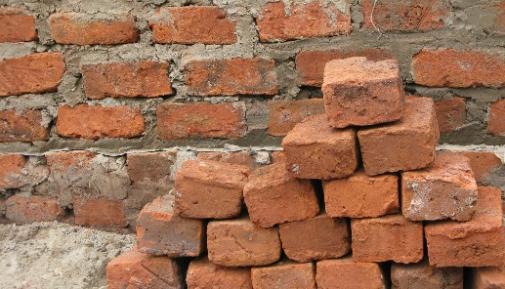
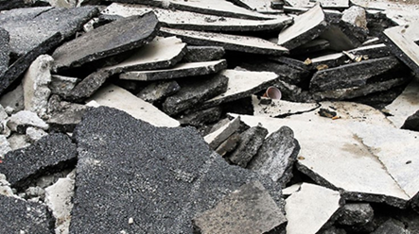
Brick / Block
Asphalt

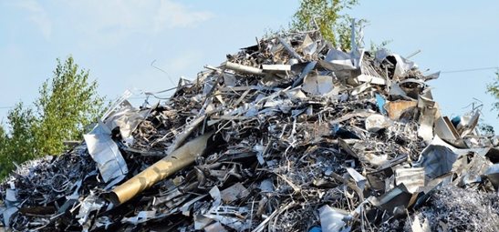
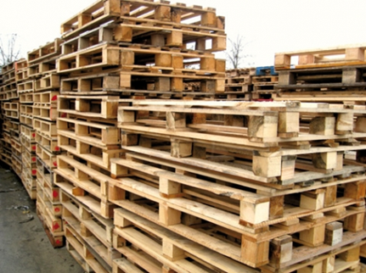

Scrap Wood / Pallets / Lumber
Scrap Metal

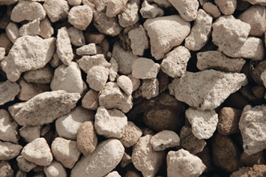
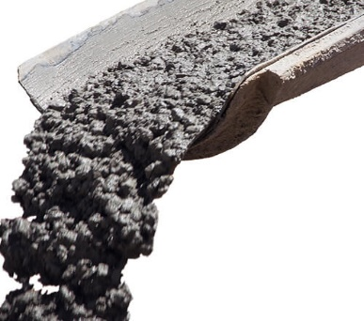
Hardened Concrete Waste
Crushed Concrete

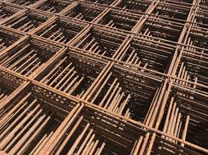
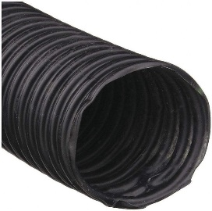
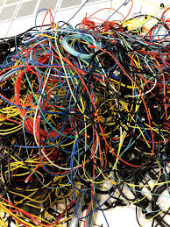
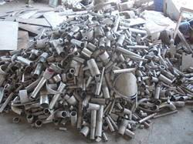
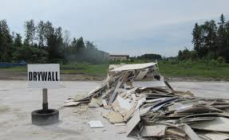
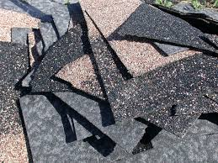
Roofing Shingles
Rebar and Wire Mesh
Corrugated Plastic Pipe
Electrical Wiring
Plumbing Waste (PVC, Metal, Plastic Pipe), and Fixtures
Drywall Waste and Hardened Drywall Mud
General Construction Waste
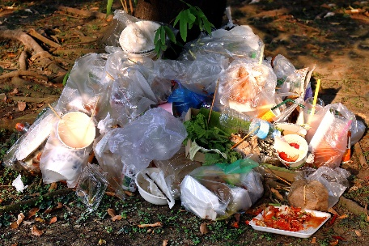
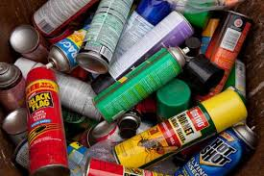
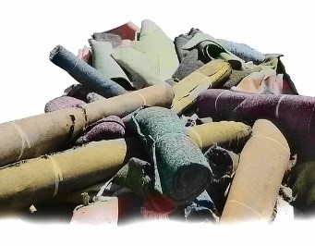
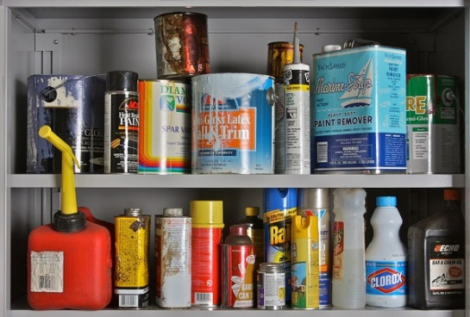
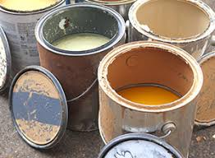
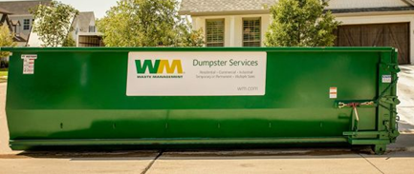
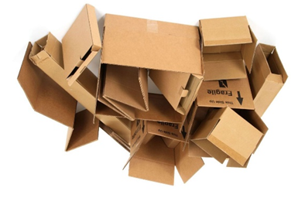
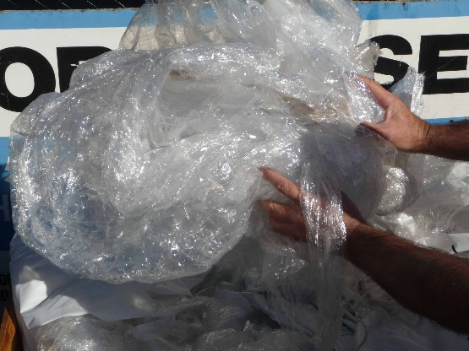
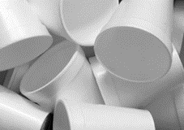
Plastic
Banding
Materials
Styrofoam Products
Aerosol Cans
Unused Paint or Other Liquid Wastes
Plastic Wrap/ Packaging and Plastic Bags
Construction Site Trash
Fabrics/ Carpeting
EXAMPLE SPECIAL WASTES
Hazardous Wastes
Food Waste and Food Packaging
Cardboard / Paper
Note: CDD should not contain any General Construction or Special Wastes
General Construction Waste and CDD Toolbox Training Talking Points
Waste Sorting
- Review each of the CDD and general construction waste items shown in the table that will be generated on this site.
  - Discuss how each of these materials will be handled and where they will be stored on the project site.
  - Review which wastes should be commingled versus segregated on-site to meet project recycling objectives
  - To discourage comingling of waste streams, clearly distinguish with signage each General Solid Waste dumpster/roll-off from the CDD dumpster/roll-off.
- Review other items generated on site that are not general construction waste or CDD and should be kept out of these collection areas.
  - Concrete washout waste must be completely dried
  - Store bulbs/lamps intact – do not crush on-site.
  - Contact [insert name of appropriate site staff] if you encounter any hazardous waste, asbestos containing material, lead paint, or any specialty wastes
  - Compressed gas cylinders
  - Aerosol cans
  - Liquids of any kind other than clear tap water / rain water
  - Clean Fill Materials – refer to toolbox training if needed

Waste Handling and Storage
- Everyone on site is responsible for ensuring that wastes are appropriately separated and that and that the container(s) are not leaking or overflowing. Don’t leave trash lying on the ground.
- DO NOT dump any liquid (or other) wastes down the storm sewer drop inlets, sanitary sewer manholes, or on the ground. If you have liquids that must be disposed of, contact your supervisor or one of the [General Contractor] staff to discuss appropriate handling.
  - Liquid waste can include wastes from mortar mixing, concrete washout, paintbrush washing, and other operations that use water
- Cover all outdoor dumpsters/roll-offs at the end of each workday and during rain events. This is to prevent rainfall from coming into contact with waste and leaking out of any holes in the dumpster.
- Inspect storage areas daily and before/after significant storm events for proper management and evidence of contamination.
  - Remove any inappropriately sorted materials and dispose of them appropriately
  - Notify [appropriate site contact name] immediately of any material suspected to be contaminated (e.g. soil material with a petroleum-type odor or leaking dumpsters).
- Visually inspect waste streams before they are hauled off site to ensure there is no contamination from other waste streams / improper waste sorting.

Report waste-related issues and concerns or questions about this toolbox talk to the UVA CAM/PM to share with UVA Environmental Resources.

